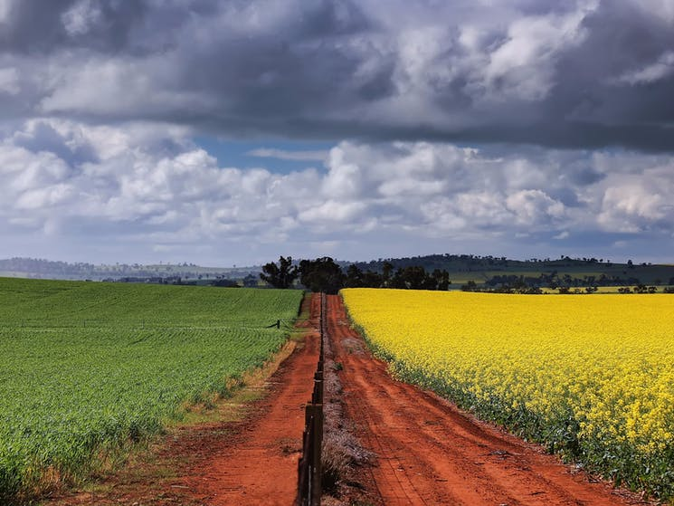

September 2026
DRAFT POLICY POSITIONS
Climate Resilience and Water Security
Policy Position Statement: Climate Resilience and Water Security
NIC Policy Positions are agreed with Members and prepared in conjunction with our Guiding Policy Principles.

- Australia’s unique climate and highly variable water availability requires a uniquely Australian approach to water security that cannot be solved by water policy alone. Policy cannot remove variability; it provides stable,robust and transparent rules to give confidence in how variable water availability and risk will be managed.

- Water security for agriculture is critical in any climate as it is. Stable rules providing for reliable water for agriculture is fundamental to our national and international food security, our regional and national economies, and must be protected and valued to maintain these relationships.

- Climate uncertainty is a collective challenge requiring Governments, communities, industry, irrigators, and the environment to all all sectors to share the risk, and cooperatively better plan and prepare for everyone to achieve more from less.

- Farmers already lead in adaption to climate to remain sustainable and globally competitive, but adaption will have limits. Future resilience depends on optimising all tools, continued investment in water-use efficiency, research and development, and climate smart, fit-for-purpose infrastructure (on farm and shared infrastructure).

- Modern, fit for purpose water infrastructure is essential to capture, store, and use water efficiently and is will be a critical climate adaption and mitigation tool needed to maintain water security for all.

- Australia’s contemporary water management framework was designed to consider climate risk and variability through:

  - Entitlement categories that represent a share of the resource and use risk-based allocation systems that reflect prevailing water availability and prioritise critical needs such as town water supplies and environmental flows for our rivers.
  - Water markets enabling water entitlement holders to manage risk, optimise water use, and respond flexibly to changing conditions.

- Proposed environmental outcomes and any future solutions must recognise water property rights and the existing water management frameworks and be informed by plausible risk. More information is needed on plausible climate risk scenarios their likelihood, and how they would translate through existing water management settings to affect and likely impacts on water availability, reliability and the environmental outcomes at local, catchment and Basin scales is needed.

Guiding Policy Principles
All NIC Policy Positions are guided by 4 overarching Policy Principles:
- Enhance and protect water property rights without altering the characteristics.
- Utilise market mechanisms to ensure no negative third-party impacts on water reliability or availability; compensate or mitigate any impacts by negotiation with affected parties.
- Governments must effectively engage industry in policy development and implementation.
- Fair and equitable policy must share risks and opportunities among all stakeholders not just water users, ensuring a balance.

Background
Linked NIC Position Statements
- Water Reliability

Policy settings
Climate variability and any change is factored into current water policy settings in the Murray-Darling Basin (MDB), as well as many other catchments in Australia. In fact, a variable climate is at the heart of the contemporary water management framework in Australia, as envisioned by the National Water Initiative (NWI), and given effect through state-planning arrangements in a variety of ways.

However, these mechanisms are complex and often poorly understood, which has created a false assumption that climate variability and change is not considered at all.

NIC has prepared a Water Security and Climate Change Report, to address that knowledge gap, by outlining the current policy settings to deal with both climate variability and change, and how climate change scenarios are expected to play out under these current settings. This is important to inform an evidence-based understanding of the status quo and make recommendations regarding future evidence gaps.

This Report comes at a critical time with the imminent 2026 Basin Plan Review, and ongoing 2027 Water Act Review, to which climate change is a key statutory consideration.

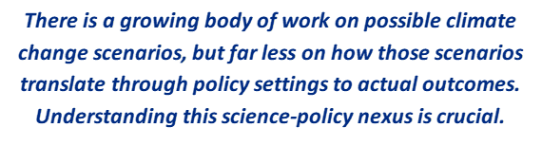
Key findings of this Report include:

- Climate variability and any change is factored into current water policy settings, at both state and federal levels. This is reflected in at least five different core measures in Commonwealth and State legislation including: risk-based entitlements, allocation systems, incident response guidelines and extreme measures, and two forms of diversion limits. This excludes localised measures within valley-based Water Sharing Plans (WSP).
- Policy has an ongoing adaptive mechanism for responding to the real-time actual hydrological consequences of a changing climate, rather than requiring ex ante predictions of water availability decades into the future.
- The application of climate change scenarios to this existing framework demonstrates how the framework responds to climate variations.
- Based on data from the NSW Government, under a dry climate future scenario, with current policy settings, the reliability of water allocations to entitlements will significantly decline.
- For example, the percentage of the time water allocations reach 100% is expected to drop, from 40% of the time to 6% in the Murrumbidgee, and from 60% of the time to 20% in the NSW Murray.
- There are parameters of what water policy can achieve (in terms of rules, regulations, legislation), and the role of other non-policy interventions (such as infrastructure, alterative water sources, planning requirements, and more). Resilience to climate change will require looking across these multiple levers.
- In the context of a variable and changing climate, water security as a policy objective is not the absence of variability; it is confidence that variability will be managed within a durable, robust, transparent and accepted institutional and policy framework. Put simply, certain water policy, to manage for uncertain water availability. For irrigated agriculture, this stability is critical to investment, productive capacity, regional economies and Australia's food security.
- Understanding possible future climate scenarios is not as simple as “less water”, rather, variations in the timing and pattern of water availability - the science is increasingly consistent on the direction of plausible change, but uncertainty remains and more work is needed to understand the scale, timing and location of potential future impacts on water availability, and how this then translates through current policy settings to produce outcomes.

Key recommendations, moving forwards, will be for:
- The MDBA maintain their draft position that “Given the wide range of plausible climate futures, the Authority is not proposing changes to the SDLs in response to climate change in 2050 through this review.”
- The MDBA to collate existing policy mechanisms at both a state and federal level of state governments to communicate how water allocations and permitted take vary in response to climate in each jurisdiction, to ensure appropriate levels of understanding of the status quo to inform decision-making and stakeholder understanding;
- The MDBA, as part of the Basin Plan Review, coordinate work with each jurisdiction to forecast likely reliability impacts to water allocations across entitlement types, in each water source, for various climate scenarios – to understand how climate scenarios will play out based on the status quo of policy settings;
- The CEWH similarly undertake a program of work to examine reliability trends of water entitlements in their portfolio under various climate change scenarios;
- The MDBA, as part of the Basin Plan Review, include explanation of how actual and permitted levels of take vary based on climate, to improve confidence in the ability of the current system to respond to climate variability and change on an ongoing adaptive basis;
- The MDBA advises as part of the Basin Plan Review that no changes to the SDL are to occur at this point in time, due to climate science not supporting a case to change SDLs within the next 10-year time period;
- The Federal Government undertake an audit of Australia’s water infrastructure, focusing on town water supplies, to assess against climate-readiness and invest funding to future-proof critical human water needs in at-risk communities;
- Expand the capabilities of My Climate View and other climate tools to include forecast trends in the reliability of water allocations to water entitlements, to be of increased value for irrigated agriculture and other water entitlement holders.
Ultimately, Australia’s unique climate and highly variable water availability requires a uniquely Australian approach to water security that cannot be solved by water policy alone. Policy cannot remove variability; it provides stable, robust and transparent rules to give confidence in how variable water availability and risk will be managed. As evidenced through this report, such policy settings are well-established in the MDB.
However, even with climate-responsive policy, there are limits to what policy itself can realistically deliver towards water security in a variable climate, particularly in extreme dry times when the water simply isn’t available.
There are a range of non-policy levers that must be considered. Modern, fit for purpose water infrastructure is essential to capture, store, and use water efficiently and is will be a critical climate adaption and mitigation tool needed to maintain water security for all. Dams and water storages are part of that conversation, but infrastructure also extends beyond that.
For agriculture, farmers already lead in adaption to climate to remain sustainable and globally competitive, but adaption will have limits. Future resilience depends on optimising all tools, continued investment in water use efficiency, research and development, and climate smart, as well as fit for purpose infrastructure (on farm and shared infrastructure).
Climate uncertainty is a collective challenge requiring Governments, communities, industry, irrigators, and the environment to share the risk, and cooperatively better plan and prepare for everyone to achieve more from less.

