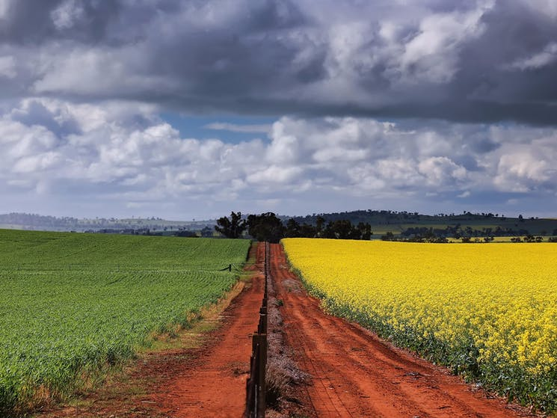

September 2026
DRAFT POLICY POSITIONS
Menindee Lakes
Policy Position Statement: Menindee Lakes
NIC Policy Positions are agreed with Members and prepared in conjunction with our Guiding Policy Principles.

- Any changes at Menindee Lakes must respect all water property rights and not impact the reliability or volume of water available to water licences across the system, either the northern or southern Basin.
- Any changes at Menindee must seek to maintain or enhance the operational flexibility of the system to fulfil the Lakes role as a storage to supply NSW, VIC and SA bulk water shares for the Murray, provide drought security, and seek to continually improve delivery efficiency.
- Any change must be consistent with (1) and (2), and any ‘environmental improvements’ must demonstrate clear, measurable environmental benefits such as improved fish populations, water quality, or habitat, and not rely on the recovery of additional volumes of water.
- Stakeholder engagement must be participatory and include affected stakeholders above, at and below the Lakes, not just Commonwealth or state officials.
- If changes to either the operation or Murray Darling Basin Agreement are identified, they must meet our industry expectations for policy assessment principles.

Guiding Policy Principles
All NIC Policy Positions are guided by 4 overarching Policy Principles:
- Enhance and protect water property rights without altering the characteristics.
- Utilise market mechanisms to ensure no negative third-party impacts on water reliability or availability; compensate or mitigate any impacts by negotiation with affected parties.
- Governments must effectively engage industry in policy development and implementation.
- Fair and equitable policy must share risks and opportunities among all stakeholders not just water users, ensuring a balance.

Background
Linked NIC Position Statements
- Water Reliability
- Expectations on Policy Impact Assessments

Policy settings
The Menindee Lakes system performs a critical and multifaceted role within the Murray-Darling Basin, functioning as a key regulating and balancing storage on the Darling River as firstly outlined within the Murray Darling Agreement (the Agreement) in 1964 and now within Part 1A and Schedule 1 of the Water Act 2007 (Cth).

The Menindee Lakes Review is being undertaken by the River Murray governments; Commonwealth, New South Wales, Victoria and South Australia with the MDBA managing the review process on their behalf. It is separate from, but closely connected to, the 2026 Basin Plan Review.

At its core, the review is asking whether the current management and operating arrangements remain fit for purpose and how the system should be managed into the future. This reflects both the age and complexity of existing arrangements and changing conditions across the Basin, including climate variability, environmental condition, water quality, connectivity, water security and the needs of communities and water users.

The August 2026 What we heard process identified broad support for improving water quality and aquatic ecosystems, reviewing current management arrangements, improving community and First Nations participation, and making decision-making more transparent.

The MDBA says the next phase is bringing community input together with technical and scientific evidence to develop a future vision for the Lakes and identify and assess pre-feasibility options and pathways for their future management. A draft vision and early options are intended to undergo further consultation.

Background of Menindee Lakes
The Menindee Lakes are a chain of naturally occurring ephemeral lakes on the Baaka/Darling River in far-western New South Wales, near the township of Menindee and downstream of Wilcannia. They occupy an important position between the northern and southern Murray–Darling Basin: the MDBA defines the Northern Basin as the rivers upstream of the Menindee Lakes, while water passing through the Lakes enters the Lower Darling and ultimately the River Murray system.

The system comprises a series of lakes, including the major regulated storages Lakes Wetherell, Pamamaroo, Menindee and Cawndilla. While the lakes are natural features of the Darling River floodplain, they have been progressively modified through weirs, regulators, channels and other infrastructure to operate as a managed water storage system. The Menindee Lakes help moderate the natural variability of the Darling River by holding water during high-flow events and releasing it in a controlled manner when flows recede, providing a critical degree of operational flexibility across the Basin.

Today, the Menindee Lakes perform several interconnected functions. They capture and regulate flows arriving from the northern Basin; provide water for local and downstream requirements; support environmental and cultural values; and can contribute water to the Lower Darling and River Murray and are part of state sharing arrangements between NSW, VIC and SA. They are not just a storage. They act as a critical, strategic control point for the entire Basin. They enable water to move from the north to the south (when available), support communities and ecosystems, and provide a buffer against extreme climate variability.

The Lakes also have significant ecological and cultural values, particularly for Barkandji people, as well as supporting native fish, waterbirds, wetlands, recreation, tourism and local communities. At the same time, their management is complex because inflows are highly variable and the system has experienced both extended drought and major floods.

Any changes at Menindee must seek to maintain or enhance the operational flexibility of the
system to fulfil its primary role as a storage to supply NSW, VIC and SA bulk water shares for the
Murray as outlined by Schedule 1 of the Water Act 2007 (Cth) – the former Murray Darling
Agreement.

