National Irrigators’ Council
October | 2026
Submission
SDL Adjustment Mechanism Draft Determination
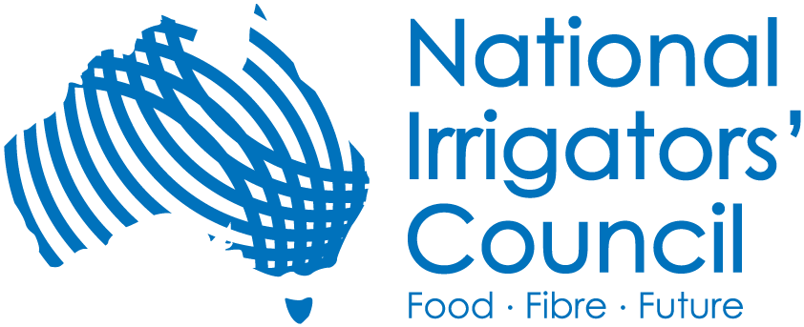

About us
The National Irrigators’ Council (NIC) is the peak body representing irrigators in Australia, supporting 31 member organisations across the Murray Darling Basin, and irrigation regions around Australia. We represent major agricultural commodity groups with members collectively holding over 5,000,000 megalitres of water entitlement. NIC is the voice of irrigated agriculture and the industries producing food and fibre for domestic consumption and significant export income.

Background
This submission is in response to the publication of the Murray Darling Basin Authority (MDBA) Draft Determination of proposed adjustments to Sustainable Diversion Limits (SDLs) resulting from the SDL Adjustment Mechanism (SDLAM).
NIC notes that this public consultation is highly technical in nature. As a result, this submission will provide additional explanations to unpack many of the key concepts and findings (Part 1), before outlining the detailed NIC positions and recommendations (Part 2), to provide crucial context to understand the NIC positions, and ensure this document can be read and understood by a broader audience.
NIC recognise a large focus of this public consultation is on the modelling aspects. This is beyond the capabilities and resourcing of most stakeholders to respond to, particularly given the details required to technically scrutinise these projects are not available, and would require more time and resourcing than the 4-week consultation allows. As a result, this submission focuses on SDLAM more broadly, its intent and deliverables and likely outcome, and provides recommendations on how the MDBA deals with the results of Reconciliation, in terms of the recommendations that go to the Minister to make a decision.

Executive Summary

Key findings
Finding 1: The Draft Determination is 424.2 GL less than the best-case scenario of the full effect of SDLAM.
Finding 2: The Final Determination is likely to be substantially different to the Draft Determination, as contributions of additional HEW are rapidly increasing as water recovery ‘contracted but not yet registered’ becomes registered, as well as ongoing recovery. This is estimated to be at least 159.5 GL variation from the Draft to the Final Determination, not considering further purchases from 30 June 2026.
Finding 3: The Final Determination is at risk of producing a negative SDL adjustment due to ongoing recovery towards the 450 GL exceeding the supply contribution. This is counter to the original policy objective of SDLAM to offset water recovery options and mitigate social and economic impacts.
Finding 4: If taking a simplified numerical approach, viewing the remainder of the implementation of the Basin Plan as simply water recovery targets - Basin community's risk losing a further ~500 GL. That is a further: 270.2 GL from Bridging the Gap (under-recovery and supply shortfall); and 228.7 of additional HEW (if the full 450 GL is pursued).
Finding 5: If taking a proper outcomes-based approach, where focusing “full implementation” of the Basin Plan back to the core objective of reducing water usage to comply with the SDLs, then full implementation has been achieved when the SDL-adjustment is neutral (i.e. 340 GL of additional HEW, assuming a 340 GL supply contribution), provided local and shared water recovery is complete. Note: this has now largely occurred.
Finding 6: If the supply contribution is only 340 GL, any further recovery of additional HEW beyond 340 GL, is going beyond implementing the Basin Plan “in full” from an SDL perspective.
Finding 7: Delivering the Basin Plan “in full” has multiple interpretations. The point in which additional HEW recovery exceeds the supply contribution, the SDL adjustment must become neutral. From an SDL perspective, this is “in full” implementation (provided local and shared recovery are complete). It is noted that projects (such as community supported constraints management) remain important in their own right, separate from achieving SDL compliance.
Finding 8: The likely final SDL adjustment (Finding 2) is inconsistent with the objective specified in the legislation for SDLAM to maintain and improve social and economic outcomes (if a negative SDL adjustment).
Finding 9: Even under the MDBA’s scenario of an even greater shortfall (300 GL), and full recovery of the 450 GL, 92% of environmental indicators across all water resource units did not register an improved score, in the MDBA’s initial SDL assessments as part of the Basin Plan Review.
Finding 10: The supply shortfall is now detached from the evidence-based on what measures are required to directly target the environmental outcome risks.
Finding 11: The environmental priorities in the Basin have substantially shifted since SDLAM was designed. Further water recovery or SDL adjustment will not deliver the environmental outcomes required.
Finding 12: Important projects under SDLAM remain important on their own merits, and pathways forward must be identified for such projects (for example, community-supported constraints management projects).
Finding 13: Water entitlement reliability remains at-risk, as the granting of reasonable excuse provisions sits with the IGWC. This places major risks on all water users, as well as substantial financial and legal liabilities on the Commonwealth Government.

Key recommendations
Recommendation 1: The MDBA publish further information to show the full extent of change at both a Basin and water source scale of the SDLAM Reconciliation, showing a comparison to a current SDL scenario, and original Basin Plan SDL scenario. This is essential for decision-makers to understand and assess the impacts (and costs), as well as for water users to understand risks.
Recommendation 2: NIC recommend that in the advice the MDBA provides to the Minister to inform decisions on the SDLAM Reconciliation, it will be critical to take an outcomes-focused approach. Put simply, one focused on the objective of SDL compliance, and actual environmental outcomes, rather than simple and arbitrary water recovery targets.
Recommendation 3: MDBA to discuss with the Minister what “in full” implementation of the Basin Plan involves, in the context of the SDLAM Reconciliation, and outstanding projects such as constraints. In our view, focus must be on SDL compliance.
Recommendation 4: The evidence-base developed as part of the Basin Plan Review must inform the recommendations provided by the MDBA to shape decision-making.
Recommendation 5: Consider the SDLAM Reconciliation as a legacy issue, and as part of the Basin Plan Review and Water Act Amendments in 2027, use the contemporary evidence-base to focus instead on projects (such as community supported constraints projects, and complementary measures), with no further changes to current SDLs.
Recommendation 6: Advice to the Minister must include briefing of the Commonwealth’s financial commitments and liabilities.
Recommendation 7a: The decisions on the SDLAM Reconciliation must await the final outcomes of the Basin Plan and other reviews, to be evidence-based decisions.
Recommendation 7b: A process is needed to give stakeholders confidence of how the Minister plans to pull together the recommendations and findings from multiple reviews into potential legislative amendments. This includes, but is not limited to, SDLAM.
Recommendation 8:
In determining how to resolve SDLAM:
- Consider it ‘complete’ at the point in which additional HEW recovery exceeds the supply contribution to create a neutral SDL adjustment; or to the extent this is not possible,
- Account for any remaining water recoveries in response to SDLAM in the same manner as the Northern Basin Toolkit, via alternative investments that are outcomes focused and not linked to water targets but include accountability for delivery, as recommended by the Inspector General of Water Compliance (IGWC).
Noting the above is the preferred option - as it enables resolution and stability and reflects contemporary water management - to the extent that SDLAM continues to operate:
- No further changes from current SDLs, as communities cannot and should not bear the burden of poor implementation by State Governments;
- There must be an ability to account for projects as they are implemented over time, in a similar manner to how ‘varying HEW’ can be added post-reconciliation;
- Flexibility is required to add new projects, via expanded criteria, reflective of today’s environmental priorities, designed in genuine partnership with communities. This may include voluntary partnerships for environmental water delivery, as well as complementary measures.

Contents
About us 1
Background 1
Executive Summary 1
Key findings 1
Key recommendations 3
Part 1: Unpacking what this all means 6
Identifying the effect of the Draft Determination on SDLs 7
Scenario analysis 7
(a) Best case scenario 8
(b) Draft Determination scenario 8
(c) Potential Determination scenarios 11
Understanding what the SDLAM Reconciliation may mean for each water source 13
Part 2: NIC Response 17
Move away from ‘buckets’ of recovery to core objective of SDL compliance 18
What does delivering the Plan “in full” look like? 19
SDLAM for socio-economic protection 19
Environment needs more than ‘just adding water’ 21
Important projects to continue 29
Incomplete projects 30
Protecting entitlement reliability 31
Risk responsibilities of the Commonwealth 31
Clarification of process going forward 32
Technical aspects of determining the determination 33
Moving Forward: How to resolve SDLAM 33
Conclusion 35

Part 1: Unpacking what this all means

Identifying the effect of the Draft Determination on SDLs
SDLs are calculated based on the following formula:
Sustainable Diversion Limit (SDL) = Baseline Diversion Limit (BDL) – Water Recovery (local & shared) + SDL adjustment
The SDL adjustment component of this, is calculated based on the following:
Figure 1: Calculation of Final SDL Adjustment for Reconciliation (source MDBA)
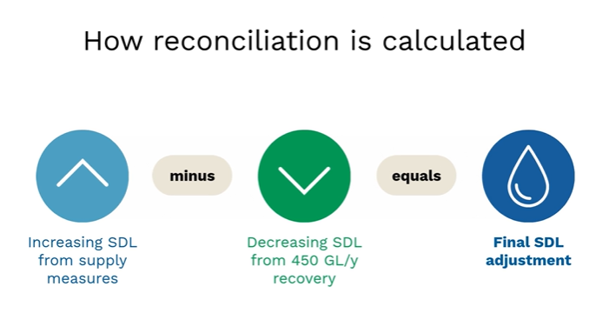

Scenario analysis
For this submission, we consider four scenarios of the final SDL adjustment, based on various contributions of supply measures and additional HEW recovery. These scenarios are outlined for explanation purposes, acknowledging the final outcome may be somewhere between these scenarios.
Table 1 below shows this scenario analysis, as explored in detail below.
Table 1: NIC Scenario analysis of Final SDL adjustments from various supply and 450 GL contributions
Best case scenario | 605 GL | - | 62 GL | = | 543 GL
2026 Draft Determination | 340 GL | - | 221.2 GL | = | 118.8 GL
Potential scenario 1 | 340 GL | - | 380.7 GL | = | - 40.7 GL
Potential scenario 2 | 340 GL | - | 450 GL | = | - 110 GL

Best case scenario
A best-case scenario under current SDLAM policy settings, would involve achieving the full 605 GL from supply measures (increase the SDL), with 62 GL of additional HEW (or efficiency measures) towards the 450 GL, which would enable the maximum SDL adjustment of 543 GL (the maximum 5% limit of change allowed under current settings).

Draft Determination scenario
The scenario presented in the Draft Determination is outlined below.
- Supply measure contribution (Draft Determination scenario)
The Draft Determination identified a proposed supply contribution of 340 GL. This is 265 GL less (i.e. a shortfall), compared to the 2017 supply contribution (or ideal best-case scenario) of 605 GL. This is shown below in Figure 2.
Figure 2: Proposed Supply Contributions under Draft Determination (source MDBA, NIC annotations)
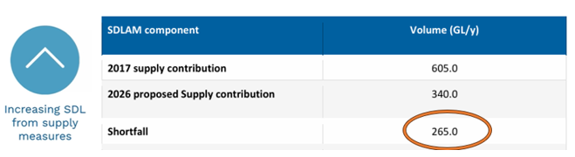
Figure 3 (from the MDBA) below shows the 2017 Determination apportioned supply contribution, 2026 Determination apportioned supply contribution, and the subsequent difference, or shortfall. NIC thanks the MDBA for providing this valley-level analysis in response to our feedback, to assist in the public consultation process.

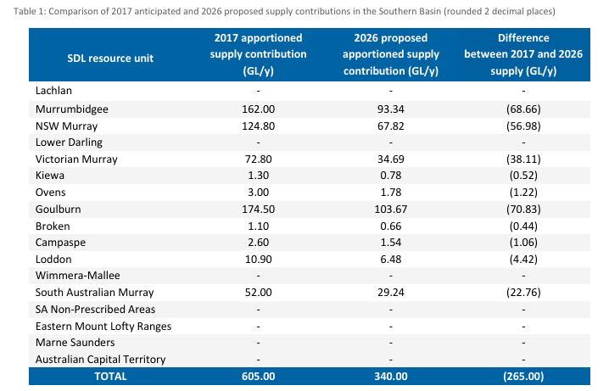
Figure 3: Proposed supply contributions under Draft Determination apportioned by valley (source MDBA)

As the MDBA makes clear:
“Importantly, the shortfall does not represent a proposed SDL adjustment amount for an SDL resource unit. Proposed SDL adjustment amounts reflect the combined effect of reconciled supply measure contributions, efficiency measure contributions and additional held environmental water contributions.”

- Additional HEW (Draft Determination scenario)
The Draft Determination identified 221.2 GL acquired as additional HEW towards the 450 GL (comprising of 28.8 GL of efficiency contribution, and 192.4 GL of additional HEW). This leaves 228.8 GL “remaining” if the Federal Government choses to maintain their policy position to acquire the full 450 GL.
Figure 4: Proposed Additional HEW Contributions under Draft Determination (source MDBA, NIC annotations)
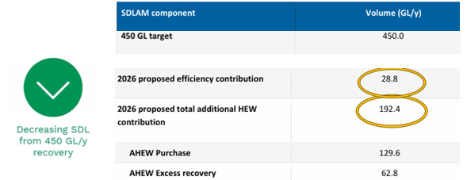

NIC understands that the contributions towards the 450 GL, as of the Draft Determination, is based on the below valley-level contributions.
Table 2: Distribution of Additional HEW contributions towards the 450 GL across SDL resource units, as of Draft Determination
SDL resource unit | Additional HEW recovery (GL/y)
Moonie | 0.8
QLD Border Rivers | 0.4
Gwydir | 5.0
Macquarie-Castlereagh | 21.7
Northern Basin total | 27.9
Lower Darling | 0.9
Murrumbidgee | 29.0
NSW Murray | 50.0
ACT | 1.5
Broken | 0.2
Campaspe | 0.3
Goulburn | 48.7
Loddon | 1.4
VIC Murray | 45.5
SA Murray | 15.7
Southern Basin total | 193.2
TOTALS | 221.3

- SDL adjustment (Draft Determination scenario)
These contributions can then be inserted into the SDL adjustment formula (Figure 1). This is how the SDL adjustment in the Draft Determination document has been produced, proposing the SDL adjustment of 118.8 GL, as shown in Table 1.
The most important point to note from the proposed SDL adjustment in the Draft Determination scenario, is that while the Draft Determination produces an SDL adjustment of 118.8 GL (i.e. SDL increase of this amount), this is 424.2 GL less than the best-case scenario of the full effect of SDLAM.
Finding 1: The Draft Determination is 424.2 GL less than the best-case scenario of the full effect of SDLAM

Potential Determination scenarios
In addition to the two scenarios explored above, there are further scenarios that must be considered.
NIC is concerned that by the MDBA choosing a lower than publicly recorded figure of contracted water recovery towards the 450GL, they have created the expectation of a positive SDL adjustment. However, the NIC note there will be significant change from the Draft Determination scenario to the Final Determination scenario, due to the pace of recovery of water towards the 450 GL.
As above, the Draft Determination only factored in 221 GL of recovery towards the 450 GL. However, reporting by DCCEEW shows that this number is already outdated. According to the DCCEEW website, as of 30 June 2026, 230 GL is registered, with another 150.7 GL contracted but not yet registered, which combined brings a total of 380.7 GL. An extract from the DCCEEW website is shown below in the below Figure.
Figure 5: Extract from DCCEEW website on recovering towards the 450 GL (source DCCEEW)
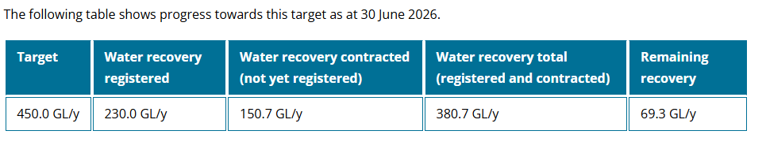
The significance of this is that there is another 159.5 GL of additional recovery, which may be expected to contribute to the Final Determination, that was not yet factored into this Draft Determination. This number may also be potentially higher as the Federal Government has expressed, they maintain their position to recover the full 450 GL, with some reports of acquiring at least 400 GL by the end of the calendar year.
Finding 2: The Final Determination is likely to be substantially different to the Draft Determination, as contributions to additional HEW are rapidly increasing as water recovery ‘contracted but not yet registered’ becomes registered, as well as ongoing recovery. This is estimated to be at least 159.5 GL variation from the Draft to the Final, not considering further purchases from 30 June 2026.
To properly respond to this public consultation process, it is therefore important to consider further scenarios, with increased contributions towards the 450 GL beyond what has been factored into the Draft Determination to date. These are explored in Table 1, with:
- Potential Scenario 1 – maintains the proposed 340 GL supply contribution, and assumes 380 GL of additional HEW;
- Potential Scenario 2 - maintains the proposed 340 GL supply contribution and assumes 450 GL of additional HEW.
As Table 1 above shows, as more water is registered to contribute towards the 450 GL of additional HEW, the final SDL adjustment decreases (assuming the supply contribution remains constant at the proposed 340 GL).
Where this becomes interesting, is that it reaches a point where the final SDL adjustment becomes negative. Put simply, that the net effect of SDLAM, produces a result where the SDL is lower, than without SDLAM. Note (as above): SDLs are calculated based on the following formula:
Sustainable Diversion Limit (SDL) = Baseline Diversion Limit (BDL) – Water Recovery (local & shared) + SDL adjustment
Therefore, a negative number for the ‘SDL adjustment’ component of this equation, produces a lower SDL. This is shown in Potential Scenario 1 which produces an SDL adjustment of – 40.7 GL, and Potential Scenario 2 which produces an SDL adjustment of – 110 GL. Put simply, if the full 450 GL is recovered, with just a 340 GL supply contribution, the SDL will be adjusted downwards by 110 GL.
Given the purpose of SDLAM was to provide a mechanism to bridge the gap to achieve the SDL in a way that protects social and economic outcomes, the (increasingly likely) scenario that SDLAM will perversely serve to lower the SDL is concerning and requires scrutiny by the MDBA.
Finding 3: The Final Determination is at risk of producing a negative SDL adjustment due to ongoing recovery towards the 450 GL exceeding the supply contribution. This is counter to the original policy objective of SDLAM to offset water recovery options and mitigate social and economic impacts.
Further from this, while ‘potential scenario 2’ produces a result in which the SDL will be adjusted downwards by 110 GL, it is important to note that the SDLs currently operating in the Southern Basin are already SDLAM-adjusted. Therefore, the impact in a practical sense to industry is not just 110 GL downwards of the SDL, but also the loss of the positive adjustment that is currently in effect in the Southern Basin. The actual extent of this number should be published by the MDBA, so that users and decision-makers can understand the full extent of the potential risks and associated impacts, compared to the status quo.
As an indication, given the best-case scenario was a positive adjustment by 543 GL, such an outcome of a negative adjustment by 110 GL, would be 653 GL less than what could have been under the best-case scenario. Note: SDLs have varied over time as recovery of additional HEW occurs.
Recommendation 1: The MDBA publish further information to show the full extent of change at both a Basin and water source scale of the SDLAM Reconciliation, showing a comparison to a current SDL scenario, and original Basin Plan SDL scenario. This is essential for decision-makers to understand and assess the impacts (and costs), as well as for water users to understand risks.

Understanding what the SDLAM Reconciliation may mean for each water source
One of the most frequently asked questions during this consultation has been what impact the SDLAM reconciliation will have, in a practical sense. Water users want to know the material impacts that the reconciliation may produce, at both a Basin and valley-scale. This material change from the status quo to a future post SDLAM reconciliation, is also critical for decision-makers to understand the practical ramifications of decision-making.
NIC is concerned that the technical complexity of the consultation documents has meant many stakeholders were left confused and not understanding the ramification of what the SDLAM reconciliation may mean in practice. NIC is concerned if that confusion extends to decision makers, who may not realise the true extent of what future decisions may be ahead.
NIC has compiled our understanding of the risks posed to each SDL resource unit in Table 5, which compiles the above information. Table 5 shows the water sources with remaining Bridging the Gap recovery, through both existing under-recoveries, and the proposed supply shortfalls (as per Figure 3). Table 5 also shows the contributions towards the 450 GL. The risks for each water source are therefore:
- Orange shaded cells (where applicable) – with remaining Bridging the Gap (supply shortfall + under-recovery), with a total of 270.2 GL Basin-wide
- Potential recovery of the remaining ~228.7 GL of the 450 GL – across water sources.
As part of Recommendation 1, NIC recommend that the MDBA publishes a document of this kind, so that the full extent of potential impacts for each water source can be transparently shown. A final column should also be included, to show the current SDL adjustment, alongside the new proposed SDL adjustment, as well as quantification of the magnitude of change – so it can be considered in the context of the proposed change.
Finding 4: If taking a simplified numerical approach, viewing the remainder of the implementation of the Basin Plan as simply water recovery targets - Basin community's risk losing a further ~500 GL. That is a further: 270.2 GL from Bridging the Gap (under-recovery and supply shortfall); and 228.7 of additional HEW (if the full 450 GL is pursued).

Finding 5: If taking a proper outcomes-based approach, focusing “full implementation” of the Basin Plan back to its core objective of reducing water usage to comply with the SDLs, then full implementation has been achieved when the SDL-adjustment is neutral (i.e. 340 GL of additional HEW, assuming a 340 GL supply contribution), provided local and shared water recovery is complete. Note: this has now largely occurred.

Finding 6: If the supply contribution is only 340 GL, any further recovery of additional HEW beyond 340 GL, is going beyond implementing the Basin Plan “in full” from an SDL perspective.
Table 5: Potential Risks for SDL Resource Units (see orange)
SDL resource unit  (or Shared Zone) | Bridging the Gap total target (GL/y) | Bridging the Gap total recovery (GL/y) | Bridging the Gap remaining (supply shortfall + under-recovery) | 450 GL target total recovery (GL/y) | MDBA Draft Reconciliation
Condamine-Balonne | 100.0 | 100.3 | - | -
Moonie | 2.1 | 2.1 | - | 0.8 | -0.777
Nebine | 3.8 | 3.8 | - | -
QLD Border Rivers | 14.0 | 14.0 | - | 0.4 | -0.416
Warrego | 20.1 | 20.1 | - | -
Barwon-Darling | 32.0 | 35.7 | - | -
Gwydir | 49.6 | 49.6 | - | 5.0 | -5.041
Intersecting Streams | 13.8 | 15.8 | - | -
Macquarie-Castlereagh | 57.6 | 57.7 | - | 21.7 | -21.688
Namoi | 20.0 | 19.4 | 0.6 | -
NSW Border Rivers | 7.0 | 2.8 | 4.2 | -
northern Basin total | 320.0 | 321.2 | 4.8 | 27.9 | -27.922
Lower Darling | 22.3 | 21.3 | 1.0 | 0.9 | -0.856
Murrumbidgee | 504.6 | 435.9 | 68.70 | 29.0 | 64.295
NSW Murray | 360.0 | 302.0 | 58.0 | 50.0 | 17.805
ACT | 4.9 | 4.9 | - | 1.5 | -1.46
Broken | 0.6 | 0.2 | 0.4 | 0.2 | 0.501
Campaspe | 29.7 | 28.6 | 1.1 | 0.3 | 1.232
Goulburn | 426.7 | 355.9 | 70.8 | 48.7 | 54.984
Kiewa | 0.3 | - | 0.3 | - | 0.778
Loddon | 15.3 | 10.9 | 4.4 | 1.4 | 5.089
Ovens | 0.9 | 0.1 | 0.8 | - | 1.78
VIC Murray | 428.3 | 391.0 | 37.3 | 45.5 | -10.854
SA Murray | 154.6 | 131.8 | 22.8 | 15.7 | 13.542
southern Basin total | 1,926.7 | 1,682.6 | 265.40 | 193.2 | 146.836
TOTALS | 2,246.7 | 2,003.8 | 270.2 | 221.3 | 118.914
 |  |  |  | ~ 228.7

Part 2: NIC Response

Move away from ‘buckets’ of recovery to core objective of SDL compliance
The core objective of the Basin Plan was to establish Sustainable Diversion Limits (SDLs), and to provide for pathways to reduce diversions in order to comply with these new lower limits. Put simply, water recovery was the means, to the end-goal of achieving compliance with SDLs.
NIC is concerned that over time the focus of the implementation of the Plan has shifted to be focused on simply acquiring water recovery targets, detached from the core purpose of what that was meant to serve, to achieve SDL compliance.
This has undermined confidence and integrity in the implementation of the Plan, as it appears Government is recovering water for the sake of it, to achieve arbitrary targets, increasingly detached from scientific reasoning, environmental outcomes, and now entirely de-linked from the primary objective of achieving SDL compliance. The Productivity Commission warned of this risk in their 2024 Inquiry into the Murray Darling Basin Plan.
From the perspective of stakeholders, the only remaining reasoning being provided for further water recovery is political motivations, such as to meet “promises” or election commitments – rather than actual contemporary scientific evidence. In fact, the science is increasingly telling a different story that the environmental pressures require direct measures, and that further water recovery (or SDL changes) cannot achieve those objectives (as explored in the subsequent section).
Recommendation 2: NIC recommend that in the advice the MDBA provides to the Minister to inform the decision on the SDLAM Reconciliation, it will be critical to take an outcomes-focused approach. Put simply, one focused on the objective of SDL compliance, rather than simple and arbitrary water recovery targets.
Specifically:
- What is required to achieve the Basin Plan’s purpose of SDL compliance, not just a simple numerical approach of progress against (now arbitrary and outdated) water recovery targets.
- What is required to address the environmental pressures in the Basin, building on the evidence base now provided through the 2026 Basin Plan Review as the contemporary best available science.
Taking a simple and siloed view of reporting progress towards water recovery targets, risks going beyond what the Basin Plan was designed to do, and risks investment in measures that are not the environmental priority for the Basin (with large taxpayer costs and socio-economic impacts).

What does delivering the Plan “in full” look like?
NIC notes the Federal Governments policy position to deliver the Basin Plan “in full”, yet there are multiple interpretations of what “in full” actually means.
In our view, a Basin Plan “in full” would be achieving full compliance with the SDLs in the Basin Plan.
As per Table 1 above, at the point in which additional HEW recovery equals the supply contribution, they effectively cancel out. This means that the SDL is neither adjusted upwards or downwards. At the point in which additional HEW recovery exceeds the supply contribution, the Basin Plan implementation is arguably going beyond the Basin Plan “in full”, as it was intended, by producing a lower SDL.
Based on the water recovery reported to date by DCCEEW (see Figure 5), it appears this threshold has already been crossed. Further water recovery beyond this point must be recognised as having the effect of lowering the SDL beyond the original SDLs (pre SDLAM).
Finding 7: Delivering the Basin Plan “in full” has multiple interpretations. The point in which additional HEW recovery exceeds the supply contribution, the SDL adjustment becomes neutral. From an SDL perspective, this is “in full” implementation (provided local and shared recovery are complete). It is noted that projects (such as community supported constraints management) remain important in their own right, separate from achieving SDL compliance.
Recommendation 3: MDBA to discuss with the Minister what “in full” implementation of the Basin Plan involves, in the context of the SDLAM Reconciliation, and outstanding projects such as constraints. In our view, focus must be on SDL compliance.

SDLAM for socio-economic protection
In the Basin Plan legislation, 5.06 “Objective and outcome for operation of the SDL adjustment mechanism” says:

“The objective in relation to the operation of the SDL adjustment mechanism is to adjust SDLs in a way that increases environmental outcomes while maintaining or improving social and economic outcomes.”

If SDLAM is to produce an SDL adjustment that is negative (as likely based on the above analysis), reducing the SDL, it is difficult to see how this could possibly be maintaining or improving social and economic outcomes.

Similarly, 7.09 says: “The objective for this Part is to allow surface water SDLs to be adjusted to reflect the effects of… :
- enhanced economic, social and environmental outcomes compared with the benchmark environmental outcomes and benchmark conditions of development can be achieved for the Murray-Darling Basin,…”

Again, if recovery of additional HEW exceeds the supply shortfall, the net effect of SDLAM is not one consistent with enhanced social and economic outcomes.

Finding 8: The likely final SDL adjustment (see Finding 2) is inconsistent with the objective specified in the legislation for SDLAM to maintain and improve social and economic outcomes (if a negative SDL adjustment).

The intention of SDLAM to operate to achieve SDLs in a way that protects social and economic outcomes, dates back to its very origins.

In the Second Reading Speech to the Water Amendment (Long-term Average Sustainable Diversion Limit Adjustment) Bill 2012, Minister Burke said:

“It is envisaged that criteria to be specified in the Basin Plan will reflect the intention of all basin governments that the mechanism must operate on a no-detriment basis. The adjustments would then not be able to weaken the social, economic or environmental outcomes inherent in the Basin Plan.

Projects that enable environmental water to be used more efficiently, thereby reducing the need to remove additional water from productive use, must achieve equivalent environmental outcomes to those in the Basin Plan. Projects to enable improved environmental outcomes, must maintain or improve the socioeconomic circumstances of basin communities compared with the Basin Plan.”

This is similarly reflected in the explanatory memorandum.

It is acknowledged that some specific social and economic protections were weakened as part of the Restoring our Rivers Act 2023. However, the intent of SDLAM remains captured in the objectives specified in the legislation.

Communities also hold concerns that the actual social and economic impacts from the Basin Plan and associated water reform are greater than currently modelled and understood. These concerns are raised in detail in the NIC Basin Plan Review, in our social and economic chapter. Major concerns relate to data limitations, requirements for social and economic reporting to occur at a Basin-scale (smoothing over localised impacts, or impacts to specific industries), and assessments occurring in a piecemeal manner (looking at each tender individually, rather than the cumulative impacts) – to name a few.

Environment needs more than ‘just adding water’
The evidence-base developed as part of the 2026 Basin Plan Review provides the best-available science on the environmental priorities in the Basin, and importantly, on the connection (or not) of further SDL adjustments towards achieving those outcomes.
As part of the initial SDL assessments, the 3 lines of inquiry examined were:
- Line of Enquiry 1: current implementation of the Basin Plan (and level of use) as at June 2024 – this line of enquiry represents the outcomes of Basin Plan implementation to date, recognising implementation is ongoing.
  - This included SDLAM projects considered complete and operational as at 30 June 2024.
- Line of Enquiry 2: full Basin Plan implementation (and full use of the SDL) – this line of enquiry represents the expected outcomes under a fully implemented Basin Plan.
  - Assumed SDLAM reconciliation has occurred and it is assumed there is a 300GL/y shortfall.
  - Assumed constraints projects will not be resolved in time for SDLAM reconciliation and, as such, constraints have not been relaxed.
  - The gap from BDL to SDL has been bridged through water recovery.
  - The recovery of 450 GL/y for enhanced environmental outcomes is complete.
- Line of Enquiry 3: full implementation under a range of plausible future hydroclimates.
Therefore, comparing the environmental outcomes between Lines of Inquiry 1 and 2 in the initial SDL assessments, can provide a reasonable indicator of environmental outcomes to inform Government decisions on how to respond to the Reconciliation.
In fact, given the supply contribution in the Draft Determination is 265 GL, the 300 GL assumed in Line of Enquiry 2 is actually beyond this (i.e. assumes an even greater shortfall), in addition to the full 450 GL.
Recommendation 4: The evidence-base developed as part of the Basin Plan Review must information the recommendations provided by the MDBA to inform decision-making.
The NIC Submission to the Basin Plan Review analysed the data provided in all initial SDL assessments in detail.
A key finding was the limited improvement between the lines of enquiry, as represented below with only 8% of assessments for individual themes across all water source units, registering an improvement.
Figure 6: Percentage of environmental themes in surface water sources with a changed outcome from LoE1 to LoE2 (extract from NIC Submission to Basin Plan Review Discussion Paper, based on MDBA data)

Finding 9: Even under a scenario of a greater shortfall, and full recovery of the 450 GL, 92% of environmental indicators across all water resource units did not register an improved score.
For example, the NSW Murray was identified as having environmental outcomes at-risk, however, no indicators changed between LoE1 and LoE2 of further water recovery (i.e. noting this is under a greater SDLAM shortfall scenario). This means even if further water recovery in response to SDLAM reconciliation, it would not improve these outcomes.
Figures 7: Extracts from MDBA Initial SDL Assessments for NSW Murray, Victorian Murray and Goulburn showing no change in outcomes from LoE1-LoE2
NSW Murray (no change)
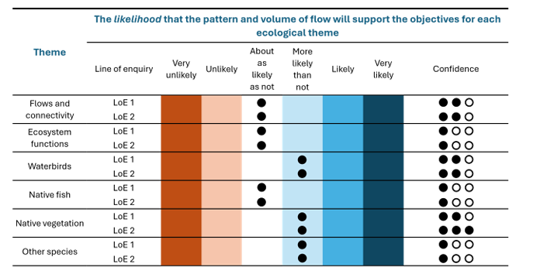
Several other water sources are similar in that there is no change shown, such as the Victorian Murray and Goulburn, as shown below. These are all water sources which face a substantial shortfall in supply contributions.
Vic Murray (no change)
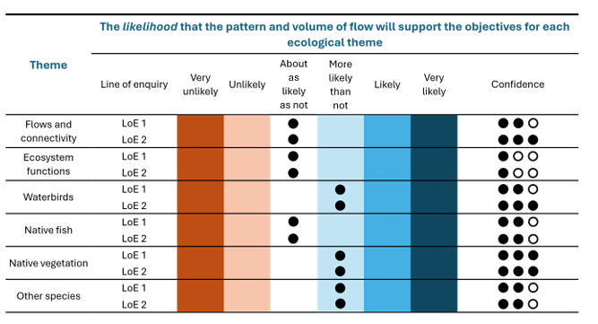
Goulburn (no change)
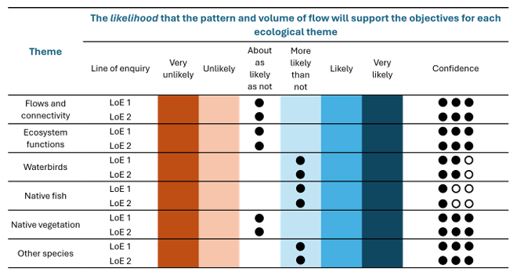
It is critical then to consider the SDLAM Reconciliation in the context of what environmental outcomes it can (or cannot) achieve.
Table 6 below compiles the supply contributions shortfalls for key Southern Basin water sources, alongside the data provided by the MDBA in the initial SDL assessments. The key findings from Table 6 are that:
- No water sources have water-sharing as the ‘problem to solve’, with most sources having pattern of flow (i.e. constraints management) as the primary driver.
- The supply shortfall is now detached from the evidence-base on what measures are required to directly target the environmental outcome risks.
Finding 10: The supply shortfall is now detached from the evidence-base on what measures are required to directly target the environmental outcome risks.
Table 6: NIC compilation of water sources with a supply shortfall, compared to the environmental outcomes identified in the MDBA’s Initial SDL assessments, with NIC analysis
SDL unit | Supply Shortfall (Draft Determination) | MDBA’s assessment of whether SDL reflects ESLT | SDL  compliance | Environmental outcome risks, identified by MDBA | Drivers of environmental outcomes at risk, identified by MDBA | Impact of further water recovery on outcomes | NIC Analysis | Is water-sharing a problem to solve?
Murrumbidgee | 68.66 | Likely | Yes | Native fish, flows and connectivity,  and native vegetation | Pattern of flow | 2 indicators change, already ‘more likely than not’ and indicators that are already scoring positively in the SRA. No change in SRA indicators scoring poorly. | No case for further water recovery / SDL changes.  For all the environmental outcomes identified as at-risk (native fish, flows and connectivity, and native vegetation) there is no change from additional water recovery (LoE1 and LoE2).  MDBA analysis in the SRA also shows the Murrumbidgee scores ‘very good condition’ for longitudinal connectivity: “The valley met 100% of longitudinal connectivity environmental watering requirements in almost all years”. Freshes and bankfull flows also scored positively in the SRA, as well as both low and high floodplain connectivity.  It is noted that constraints management was not factored into the MDBA assessments. The initial SDL assessment says, “These measures [NSW Reconnecting River Country Program Murrumbidgee Project] … would substantially alleviate the risks identified in this assessment”. This is not a water-sharing issue, rather a water delivery issue. Changing the SDL or recovering more water would not be effective against these environmental risks. | No
NSW Murray | 56.98 | Likely | Yes | Flows and connectivity, ecosystem functions and native fish | Pattern of flow | No change | MDBA analysis shows no change in environmental outcomes from further water recovery. Therefore, there is no case for further water recovery / SDL changes. | No
SA River Murray | 22.76 | Unable to determine, further work required | Yes | Flows and connectivity, ecosystem functions, native fish and waterbird | Pattern of flow (due to constraints) likely, sufficiency of flow also potential factor. | 3 + 1 change respectively (channel + Coorong / Lower Lakes assessments), already ‘more likely than not’ for SA River Murray and ‘about as likely or not’ for Coorong / Lower Lakes. | Flow versus entitlement analysis for SA suggests on average 5% of flows (1969-2025) are available as entitlements, indicating that water-sharing is not the issue and there is no case for further water recovery / SDL changes.  The objectives specified in the Basin-Wide Environmental Watering Strategy (a component of the Environmental Watering Plan) were developed in 2014, and since that time, there is new science that questions whether those objectives remain feasible, fit-for-purpose or reasonably achievable (and if so, at what cost). This must be reviewed, and realistic objectives identified, with a view to what remains plausible with climate futures, against triple-bottom-line objectives.  For the SA River Murray Channel and Floodplain, the outcomes that improved from LoE1 to LoE2 were already ‘more likely than not’ at present. The drivers specify “flow constraints have limited overbank flows and lateral connectivity, preventing environmental water delivery to many wetland and floodplain ecosystems” – this would not change via SDL changes or further water recovery.  For the CLLMM, only 1 theme changed from LoE1 to LoE2 from considerable further water recovery. Exploring alternative measures to achieve revised fit-for-purpose outcomes is needed. | No
Vic Murray | 38.11 | Likely | Yes | Flows and connectivity, ecosystem functions and native fish | Pattern of flow (due to inability to deliver water onto floodplains) | No change | MDBA analysis shows no change in environmental outcomes from further water recovery. Therefore, there is no case for further water recovery / SDL changes. | No
Kiewa | 0.52 | Confident | Yes | Not at risk |  | N/A | MDBA analysis shows confidence in the SDL reflecting an ESLT, therefore no case for further water recovery / SDL changes. | No
Ovens | 1.22 | Confident | Yes | Not at risk |  | N/A | MDBA analysis shows confidence in the SDL reflecting an ESLT, therefore no case for further water recovery / SDL changes. | No
Broken | 0.44 | Confident | Yes | Not at risk |  | No change | MDBA analysis shows confidence in the SDL reflecting an ESLT, therefore no case for further water recovery / SDL changes. | No
Goulburn | 70.83 | Likely | Yes | Flows and connectivity, ecosystem functions and native vegetation | Pattern of flow (inability to deliver higher in-channel flows and water to the floodplain in the lower Goulburn River) | No change | MDBA analysis shows no change in environmental outcomes from further water recovery. Therefore, there is no case for further water recovery / SDL changes. | No
Campaspe | 1.06 | Confident | Yes | Not at risk |  | No change | MDBA analysis shows confidence in the SDL reflecting an ESLT, therefore no case for further water recovery / SDL changes. | No
Loddon | 4.42 | Confident | Yes | Not at risk |  | No change | MDBA analysis shows confidence in the SDL reflecting an ESLT, therefore no case for further water recovery / SDL changes. | No

Based on the information in Table 6, there is a critical need to reconsider the value of the SDLAM Reconciliation, and potential Government responses to it, in the context of today’s evidence-base on environmental needs and risks in the Basin. If decision-makers were to start fresh, based purely on todays’ environment and science, there is no case for further water recovery. It will be critical for the MDBA to consider if SDLAM - as an SDL adjustment mechanism - (and further water recovery generally) has become an outdated legacy issue. This of course recognises that many of the projects under SDLAM (particularly constraints management in some form) remains important for achieving environmental outcomes in their own right – rather than just as an offset, or SDL adjustment.
The focus on volumetric equivalence should be critiqued as part of this, noting these projects have significant environmental importance on their own merits, that cannot be substituted for further water recovery.
Finding 11: The environmental priorities in the Basin have substantially shifted since SDLAM was designed. Further water recovery or SDL adjustment will not deliver the environmental outcomes required.
Recommendation 5: Consider the SDLAM Reconciliation as a legacy issue, and as part of the Basin Plan Review and Water Act Amendments in 2027, use the contemporary evidence-base to focus instead on projects (such as community supported constraints projects, and complementary measures), with no further changes to current SDLs.

Important projects to continue
As above, many of the projects in SDLAM have important environmental value. For example, “Relaxing constraints in the Murray–Darling Basin’s rivers is necessary to maximising environmental outcomes using water recovered under the Basin Plan 2012”. Part of the MDBA’s advice relating to the SDLAM Reconciliation must involve identifying future plans for these projects. Where considerable investment has gone into projects, and environmental merit remains with community support, they must continue to progress.
For example, the Constraints Roadmap identifies that: “Successfully relaxing constraints across the Basin requires a 10-year program…”.
Finding 12: Important projects under SDLAM remain important on their own merits, and pathways forward must be identified for such projects.

Incomplete projects
It could be interpreted that the Basin Plan's reconciliation provisions distinguish between whether a measure is operational, and what contribution the measure is expected to make when it operates.
This nuance is different to the typical interpretation that the Reconciliation is simply about determining whether projects are operational at that point in time, or not.
Distinguishing between the two interpretations is important.
Section 7.15(1) of the legislation includes a note: “The determination is based on the effect that the supply measures will have when they come into operation, whether or not they have done so by the time the measures are notified under section 7.12. The additional supply measures were not included in this provision at the time adjustments were proposed under section 7.10.”
Section 7.21(2) requires the MDBA to determine the efficiency, supply and additional HEW contributions "as they are expected to be on 31 December 2026."
The question is – how should “as they are expected to be”, be interpreted? If a project is expected to be operationalised in coming years, do we still ‘expect’ this outcome at the point in time of Reconciliation, even if we don’t have that outcome at Reconciliation?
It is noted that there is a common interpretation (including MDBA) of this to mean projects need to be operationalised by that date – however - if we base interpretation off the same construct as the 2017 Determination, it could be interpreted to reflect the contribution the measure is expected to make when it operates, irrespective of the status at the point in time of the determination rather what expectations could reasonably be made at that point in time.
Clarification of this interpretation is important, particularly in the context of several projects that are incomplete at the time of Reconciliation, but can still be expected to make valuable contributions once they do indeed become operations.

Protecting entitlement reliability
A major concern of water users given the SDLAM Reconciliation is protecting the reliability of water entitlements.
It is noted that the SDLAM Reconciliation Framework states:
“The Basin Plan’s existing SDL accounting arrangements will mean that with lowered SDLs there will be no impact to the reliability of entitlements. This is because the Basin Plan allows for an adjustment for incomplete water recovery.”
While it is pleasing to hear this statement from the MDBA, NIC remains concerned, as we understand this to be at the discretion of the IGWC to determine if a ‘reasonable excuse’ is accepted. Therefore, we are concerned that the risks remain.
We are also concerned that such a scenario of actively relying on reasonable excuse provisions would undermine public confidence in both water management, and industry social licence, if there was a perception of non-compliance with SDLs, given the general public will not appreciate that the gap is a result of project under-delivery by State Governments. Seeking an agreed resolution prior to such a situation developing will be critical for all parties.

Risk responsibilities of the Commonwealth
It is noted that as part of the Intergovernmental Agreement on Implementing the Murray Darling Basin Plan:
“2.2 The Commonwealth has committed to ‘Bridge the Gap’ between Baseline Diversion Limits (BDLs) and Sustainable Diversion Limits (SDLs) in the Basin Plan. As a result, it is intended that no water entitlements will be eroded or compulsorily acquired as a result of the Basin Plan.”
“11.1The Parties note that under the risk assignment provisions in the Water Act and the Basin Plan, the Commonwealth is responsible only for risk obligations resulting from reductions or changes in reliability based on the difference between the BDL and the SDL, as enforced from 2019.
11.2 Subject to compliance with the ‘Bridging the Gap’ provisions of this Agreement, the obligation to ‘Bridge the Gap’, including through SDL compliance arrangements, will not at any point be passed from the Commonwealth to the States.”

This relates to the agreed Risk Assignment Framework in the Intergovernmental Agreement on the National Water Initiative (NWI) and Agreement (NWA).
As part of the MDBA’s advice to the Minister on the SDLAM Reconciliation, it will be important to remind the Minister of these Commonwealth commitments and obligations. This is because the financial liabilities of the Commonwealth must be understood as part of decision-making.
NIC would consider lowered SDLs through reliability impacts as the worst-case scenario as a major violation of the water property right. It is important that the Minister understands the financial liabilities that would arise for the Commonwealth if such an outcome was to occur. Recognising such costs is a critical part of decision-making on alternative options, which provide better outcomes at substantially lower costs.
Finding 13: Water entitlement reliability remains at-risk, as the granting of reasonable excuse provisions sits with the IGWC. This places major risks on all water users, as well as substantial financial and legal liabilities on the Commonwealth Government.
Recommendation 6: Advice to the Minister must include briefing of the Commonwealths financial commitments and liabilities.

Clarification of process going forward
Communities are facing uncertainty of the process ahead. It is noted in the SDLAM Reconciliation Framework:
“The SDL accounting provisions within the Basin States’ water resource plans automatically allow this changed SDL limit to be adopted in the SDL accounts. If legislative amendments are in effect by 30 June 2027, new SDLs will apply for the 2027 – 2028 water year.”
However, there is also understood to be substantial legislative change potentially occurring in 2027, resulting from the Basin Plan Review and Water Act Review (and more). Given the extent of possible reform and impacts, communities are anxious, feeling uncertain, and worried about next steps.
We understand the Minister will be receiving the recommendations of numerous reviews, around a similar time, but mostly after the Reconciliation date.
Recommendation 7a: The decisions on the SDLAM Reconciliation must await the final outcomes of the Basin Plan and other reviews, to be evidence-based decisions.
Recommendation 7b: A process is needed to give stakeholders confidence of how the Minister plans to pull together the recommendations and findings from multiple reviews into potential legislative amendments. This includes, but is not limited to, SDLAM.

Technical aspects of determining the determination
NIC note a large focus of this public consultation is on the technical and modelling aspects of SDLAM. This is beyond the capabilities and resourcing of most stakeholders to respond to, particularly given the details required to technically scrutinise these projects are not available, and would require more time and resourcing than thus consultation allows.
NIC has thus chosen to focus on shaping how the MDBA deals with the results of reconciliation, in terms of the recommendations that go to the Minister to make a decision.

Moving Forwards: How to resolve SDLAM
The recommended approach to address SDLAM is one that prioritises future investment in solutions which directly target the environmental risks (which evidence shows cannot be achieved via further water recovery or SDL adjustment), while protecting communities and industries from even further water recovery or SDL adjustment.
It is important also to factor in reform fatigue, and the ongoing instability posed by ‘threats’ of further water recovery. This is particularly pertinent in situations where communities carry the risks of poor or delayed implementation, but the powers to do the implementation are with the States. Learnings from SDLAM implementation show that having important projects linked to ‘threats’ of further water recovery, makes seeking genuine community support and trust very challenging.
There are also learnings in regard to volumetric equivalence. As the MDBA now rightly points out,
“When the Basin Plan commenced it was assumed that water for the environment to key sites would be sufficient to maintain ecological health across the Basin. We have learnt it is more complex and challenging than this…”
“…deliveries of water for the environment alone are not sufficient. Other measures, such as water quality management, riparian and floodplain management, pest control, instream habitat, river operations, constraints and works, and environmental water portfolio management are crucial to the achievement of long-term environmental outcomes.”
As understandings of Basin water management have matured over time, the value of projects in their own right, rather than just as a water recovery offset, have become increasingly recognised.
It is recognised that there are limitations in the role and jurisdiction of the Federal Government and MDBA to specifically water (as per legislative requirements), however, given the evidence-base is showing the importance of integrated and complementary measures (alongside water management) – focus must not shift to how future governance arrangements can look to manage for these outcomes.
Recommendation 8:
In determining how to resolve SDLAM:
- Consider it ‘complete’ at the point in which additional HEW recovery exceeds the supply contribution to create a neutral SDL adjustment; or to the extent this is not possible,
- Account for any remaining water recoveries in response to SDLAM in the same manner as the Northern Basin Toolkit, via alternative investments that are outcomes focused and not linked to water targets but include accountability for delivery, as recommended by the Inspector General of Water Compliance.
Noting the above is the preferred option – as it enables resolution and stability and reflects contemporary water management - to the extent that SDLAM continues to operate:
- No further changes from current SDLs, as communities cannot bear the burden of poor implementation by State Governments;
- There must be an ability to account for projects as they are implemented over time, in a similar manner to how ‘varying HEW’ can be added post-reconciliation;
- Flexibility is required to add new projects, reflective of todays environmental priorities, designed in genuine partnership with communities. This may include voluntary partnerships for environmental water delivery, as well as complementary measures.

Conclusion
Thank you for your consideration of the issues raised in this submission.
Please feel welcome to contact us if you have any questions or require any further information.

2026 Sustainable diversion limit adjustment mechanism draft determination – reports and supporting documents | Murray–Darling Basin Authority
SDL resource unit level supply contributions comparison (2017 and 2026)
DCCEEW website presents a figure of 230GL (see Figure 5 below)
Productivity Commission Murray Darling Basin Plan Inquiry –Implementation Review 2023
ParlInfo - BILLS : Water Amendment (Long-term Average Sustainable Diversion Limit Adjustment) Bill 2012 : Second Reading
ParlInfo - Water Amendment (Long-term Average Sustainable Diversion Limit Adjustment) Bill 2012
National Irrigators' Council - 'Moving Forward' Our Review of the Murray Darling Basin Plan
Initial Sustainable Diversion Limit Assessments - Summary of Assessment Approach [P 7].
Sustainable Diversion Limit assessments - surface water - Groups - MDBA Library, see document for each valley.
Based on MDBA Registers of Take (2023-24, most recent), see final column ‘was the trigger exceeded’: 2023-24 Sustainable Diversion Limit Accounts
Sustainable Diversion Limit assessments - surface water - Groups - MDBA Library, see document for each valley.
Ibid.
Based on MDBA Initial SDL Assessments, and comparison of LoE1 to LoE2.
Average total flow data for 1969-2025 equals 6,851GL whereas total entitlement for agricultural use is 354GL (total 608GL minus 254GL of environmental water entitlements via Environment SA) , although use can be higher and lower than this entitlement volume due to trading (in and out of SA) and lower water availability during drought management arrangements.
No figure provided in SDL assessments as “The flow regime remains relatively intact and expected to sustain water-dependent ecosystems.”
No figure provided in SDL assessments as “The flow regime remains relatively intact and expected to sustain water-dependent ecosystems.”
Constraints Relaxation Implementation Roadmap
Constraints Relaxation Implementation Roadmap
Sustainable Diversion Limit Adjustment Mechanism (SDLAM) Reconciliation Framework [P 17].
Intergovernmental Agreement on Implementing the Murray Darling Basin Plan
Sustainable Diversion Limit Adjustment Mechanism (SDLAM) Reconciliation Framework
2025 Basin Plan Evaluation | Murray–Darling Basin Authority [P 4].
2025 Basin Plan Evaluation | Murray–Darling Basin Authority [P 42].

