Executive Summary
A national food security strategy requires a national water security strategy for agriculture to underpin it. Water is a critical input into agricultural production, and the objectives of this strategy cannot be achieved in the absence of agricultural water security.
NIC strongly supports the development of a national food security strategy – but urge it to be expanded to include food sovereignty and enable better policy alignment and integration across multiple portfolios. Wiithout better alignment and integration the Government risks undermining the objectives of the strategy through policy and actions in other portfolios and vice-versa. We explore this in our case study of Australia’s Food Bowl the Murray Darling Basin, which highlights how this Strategy is being developed simultaneously to the Federal Government continuing to reduce water available for agricultural production. With 1 in 3 litres of water for agriculture in the Basin now removed from production, we have already seen a significant change to the sector and irrigation-water dependent communities and businesses.
Key recommendations
- Include water security for agriculture as a key pillar of the strategy.
- Integrate other policy portfolios to the objectives of this Strategy, such as water and climate, to work towards this common goal consistently.
- Secure and protect agricultural water security by not removing more water from the agriculture sector.
- Continue Research and Development investment on practical, tactical options for farmers to adapt and innovate to a changing climate to maintain and increase productivity with a focus on water use efficiency.
- Improve data collection on agricultural production and drivers of change for agriculture, such as water security.
- Expand the food security strategy to include Australia’s food sovereignty.

Introduction
The National Irrigators’ Council (NIC) welcomes the opportunity to contribute to this discussion paper – Feeding Australia and provide input on behalf of the Australian Irrigation Industry.
Irrigated agricultural is essential to Australian’s and many around the world producing food such as milk, fruit, vegetables, rice, grains, sugar, nuts, meat and other commodities such as cotton and wine. The total gross value of irrigated agricultural production in Australia is highly variable due to cycles in water availability but is estimated to be approximately $18 billion - noting the Australian Government is no longer collecting real data on its value.
It is this lens of our contribution to food and fibre production, made possible through secure and reliable water access entitlements that drives our interest in the Government’s plan to develop a national food security strategy, and is why Australia also needs a national water security strategy for agriculture aligned with the national food security strategy. A food security strategy that overlooks water security for farming will almost certainly fail. With water as an essential input to agricultural production, water security must be a key focus.
Australia’s progress on national water reform that established water as a property right, has driven industry efficiencies and sustainability in developed areas, and making smarter infrastructure investment decisions in emerging regions. The reform journey and lessons have ensured Australian water sharing foundations are world leading - they adapt to our variable climate seasonality; ensure water sharing is within global standards and have increased water use efficiency.
However, there are inconsistencies in Government policy areas that undermine the future of the industry to continue to plan and invest in new technologies and innovation and maintain our international competitive advantage. Two key areas we are concerned with include water policy, particularly but not limited to in the Murray Darling Basin and national preparedness for future climate risk.
Our case study on the Murray Darling Basin highlights how the Federal Government’s water policy approach which has removed 1 in 3 litres from production, appears contradictory to the purpose and objective of this Strategy. This reform has reduced agricultural production in our food bowl, re-shaped food growing industries, reduced the number of businesses and regional economic activity by focusing on a single lever response to environmental concerns. A new approach is needed that addresses the contemporary environmental issues in the Basin without community and industry impacts.
Furthermore, the recent National Climate Risk Assessment indicates a real risk of severe water security crisis for agriculture. The impacts are stark in the Murray Dalring Basin, where potential future water security risks could undermine the $13 billion reform. A conversation on the priorities and preparation for a changing climate must occur considering water security for people and agriculture.
In Australia, we do have the management foundations, technology and innovations to increase productivity, in a sustainable and balanced way to meet future demands for clean, green and reasonably priced food and fibre. However, secure and sustainable water for production will be key input to meet our national and global responsibilities.
However, we remain frustrated that Governments continue to silo their policy responses to issues no to mention the current misalignment of Government policies, undermines the effectiveness of any Strategy to encourage improved food security. We live in increasingly complex, global system and we must adapt our policy levers to match this complexity. With that in mind, we must broaden the lens of food security to consider food sovereignty and consider climate impacts, as well as water security for agricultural production.
We have focused our feedback on the Government’s Priority Areas are of productivity, innovation and economic growth and how Government policies must create the certainty needed for industry to continue to be innovative and productive, enabling them to do their job of growing clean, green, food and fibre, and drive economic growth of the regions and the nation. Uncertainty in Government policy has the potential to undermine ongoing investment and potential economic growth in irrigated agriculture.

About us
The National Irrigators’ Council (NIC) is the peak industry body for irrigated agriculture in Australia. NIC is the voice of irrigated agriculture and the industries producing food and fibre for domestic consumption and significant international trade. Put simply, our industry is helping to feed and clothe Australia and our trading partners.
Irrigated agriculture in Australia employs world leading practices in water management. Industry has extensively adopted and embraced new technologies and knowledge to ensure we are consistently growing more with less water. Australian farmers also operate under strict regulations and compliance mechanisms. These factors mean we lead the world in both farming practices and produce quality.
NIC’s policy and advocacy are dedicated to growing and sustaining a viable and productive irrigated agriculture sector in Australia. We are committed to the triple bottom line outcomes of water use - for local communities, the environment, and for our economy.

Contact
Mrs. Zara Lowien, CEO  Office 8, Level 3, 14-16 Brisbane Avenue, Barton, ACT 2600  ABN: 92 133 308 336 | P: 02 6273 3637  E: ceo@irrigators.org.au  W: www.irrigators.org.au  X: @Nat_Irrigators

Questions for discussion

What other principles should government, industry and community prioritise to support the development of the strategy and why are these important?
Whilst we support the current principles:
- Whole food system
- Collaborative
- Ambitious and forward looking
- Outcomes based and practical
Whole food system principle: This principle must include a clear and direct, consideration on water security for agriculture food production as a key principle. This links with the United Nations Sustainable Development Goals for zero hunger and clean water for sanitation.
Furthermore, the National Climate Risk Assessment recently indicated:
Changes in water security could significantly impact agriculture due to increases in extended and severe dry periods, variable rainfall, and aridity.
Whilst not all food is irrigated, 93% of Australian fruits and nuts and 83% of our vegetables for example need water to maintain current quality and supply. These systems are most at risk due to current policy settings and climate change and therefore need broader consideration in the principles.
Collaborative principle: any Strategy must keep farmers, the produces of the food, at the heart of the Strategy. This includes listening and responding to the needs of the agriculture sector who ultimately deliver the food security outcomes.
Outcomes based and practical principle: a key part of this principle should be alignment with other policy portfolios, so other efforts (and expenditure) by the Federal Government are not in direct contradiction with the Strategy (such as what is currently occurring with the Murray-Dalring Basin Plan, and ongoing water recovery). Integration and alignment with other policy portfolios to the objectives of this Strategy, such as water and climate, should work towards this common goal consistently. Without it there is a real risk of undermining the performance of this Strategy by decisions in other areas.
Furthermore, to be practical for farmers this strategy must respect the current market-based systems, in which farmers determine what to produce, with their available inputs, based on market conditions. For irrigators this is the water management foundations outlined within the National Water Initiative and their state legislation.
Adaptation principle: a principle of flexibility and adaption should also be included as to ensure the strategy is regularly monitored, reported and reviewed.

What timeframe should the strategy work towards – short (1 to 2 years), medium (5 to 10 years) or long (10-plus years) term, and why?
Given the complexity of the Strategy and the need for improved integration of the food system, we recommend a minimum of 10-years for the Strategy.
We note that we do not support a static plan, rather an adaptive flexible plan that adjusts throughout the implementation term.
Suitable funding for implementation for the duration of the strategy should be secured.

Are there examples of current or planned initiatives by you or your organisation to improve food security in your sector?
The Australian irrigation industry is world leading in water use efficiency. For example:
“The Australian rice industry leads the world in water use efficiency. From paddock to plate, Australian grown rice uses 50% less water than the global average. Water use per hectare continues to decline because of the industry's commitment to developing high yielding rice varieties that use less water, and the use of world's best management practices.”
“Water-use efficiency has increased by approximately 240 percent since the 1970’sand Australian cotton growers are now recognised as the most water-use efficient in the world and three times more efficient than the global average. In addition, Best Management Practices programs, Integrated Pest Management strategies and the use of biotechnology reduced”
The water use efficiency story was a function of collaborative investment and innovation, between research and farmers, as well as policy foundations. The National Water Initiative (2004) set a blueprint to recognise water access entitlements as a water property right – secure, defined, mortgageable and tradable, to drive efficiencies and establish nationally consistent water management. This allowed water to move between farms and regions (within rules), to the highest value use. Research and development partnerships then ensure farmers remained on the forefront of technology and innovations to make the best use of the water available.
However, the recent Climate Risk Assessment – Risks to Primary Industries and Food report, indicated that whilst adaption and innovation is a feature of the agricultural sector, it was unclear if the current approaches would be sufficient1. This means whilst it is critical we consider ongoing Research and Development into adaption and resilience, and water use efficiency that other investments maybe required to secure our agricultural productivity.
Any future solutions must recognise the established water management foundations but must also consider the practicalities of an uncertain future climate. With this in mind, we consider it appropriate to ask the question whether our existing water infrastructure is fit for purpose to meet the future challenges of water security in a changing climate to enable resilient food and fibre production systems.
Smarter Irrigation for Profit – A Case Study
Smarter Irrigation for Profit supported research in areas including new irrigation technologies including new sensors, advanced analytics to improve irrigation scheduling and strategies to reduce water storage evaporation. A partnership between the irrigation industries of sugar, cotton, grains, dairy and rice, research organisations and farmer groups it supported a network of 46 farmer led optimised irrigation sites and key learning sites located on commercial farms across Australia.
The project ran 2015-2022 with the Phase 2 focusing on four project themes; develop new innovative technologies, optimised benefits for irrigation systems, closing the irrigation yield gap through best practice and improve the science and water foot printing of Australian agriculture.
Economic analysis highlighted of the precision irrigation program that an average water productivity increase of 18% (range 11% to 33%, median 11%) and an average multi-factor productivity increase of 59% (range 5% to 165%, median 8%) was achieved. Often the largest gains were labour savings for multi-factor analysis.
A key outcome was further evidence to highlight the potential trade-off between single-factor productivity elements highlights the importance of evaluating multiple considerations when making investment decisions, this is relevant considering the need for climate adaptation approaches (such as conversion to new water efficient irrigation technologies) in the context of wider climate change mitigation strategies (such as reduced greenhouse gas emission) to optimize both economic and socioenvironmental outcomes. Suggesting the next efforts could be focused on systems and technologies aligned with improved water use efficiency and lower emissions intensity (from reduced irrigation energy use) included: applying automation sensors and crop modelling across cotton, sugarcane, and rice sectors, moving to furrow irrigation from big gun application in sugarcane, and increasing farm output with less water in irrigated grains.
Some key Case Studies include:
Dairy example Tasmania,
Grains case study Victoria
Sugarcane Case study
Automation rice case study

Alternatively, the Murray Darling Basin Plan as a reform demonstrates the consequences of policy settings that are inflexible and narrow and can impact food system production. The following Murray Darling Basin Plan – A Case Study, highlights the real and apparent policy question:
Will continuing to remove water from agriculture production enable the achievement of environment objectives or are there other options, to achieve the same or better environmental outcomes that do not further risk our communities and industries? What is the effect of climate change on this policy approach?
We encourage the National Food Security to consider all current Government policy approaches to water and climate and how they intersect with a future plan for more secure and sustainable food.

Murray Darling Basin Plan – A Case Study
The Murray-Darling Basin Plan 2012 (Cth) ‘the Basin Plan’ forms part of a multi-decade water reform journey.
The Basin Plan is primarily about water-sharing, to address the key issue of over-allocation, following the Millenium Drought.
It has achieved what it set out to do – to set, and reduce diversions to, Sustainable Diversion Limits (SDL) that came into effect in 2019 and the most recent reporting indicating full compliance. With over 2,132.7 GL/y has been recovered from consumptive users for the environment (exceeding the 2,075 GL/y total). This means approximately one in three litres of irrigation water is now for the environment (representing the 7 percent of diversions below) that equates to 72% of river flows for the environment.
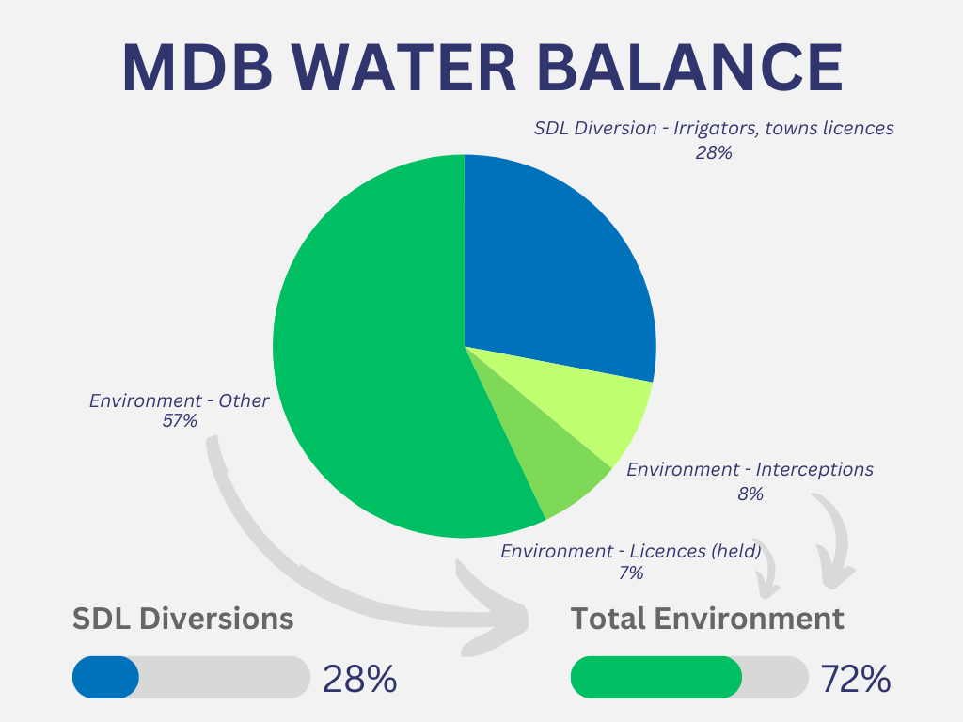
Socio-economic analysis methodologies are poor and often underestimate the impact of the reform or communities and industries. However, water reforms that reduce irrigation water supply and affordability, trigger ripple effects across communities. Evidence shows the Basin Plan has had negative socio-economic outcomes. This is often more pronounced in smaller, more remote communities and those industries and communities that are more highly dependent on irrigated-agriculture.

Innovation in technology, improvements in water use efficiency and changing crop choice have masked the impact on food systems in some areas of the Basin. However, a report by Dairy Australia in 2025 highlighted that milk production in the MDB has fallen by approximately 25% since 2012, driven by farms exiting the industry, shifting land uses, and water availability constraints, this was higher than the previous estimates by ABARES as part of the regulatory impact assessment.

For more information visit our Website – Moving Forwards our Review into the Darling Basin Plan

Do the proposed key priority areas and whole of system considerations adequately represent the actions needed for an effective food security strategy? If not, what is missing?

The missing part is the need for integration across the broad range of policy portfolio areas that impact on the agriculture sector.

As outlined above, we are seeing the Federal Government developing this Strategy at the same time as they are actively buying back more and more additional water from farmers (above the Basin Plan mandatory targets to achieve compliance with Sustainable Diversion Limits). This is reducing the pool of water available for farming in the Murray Darling Basin, as well as increasing the price of water on the market. This Strategy must take a broader look at the multiple driving forces behind changes in the agriculture sector, including key risks and vulnerabilities (many of which are being driven by Government). Realising the desired outcomes of this strategy will require other policy areas working towards these, as shared objectives, not in isolation.

A further missing piece is the need for improved data. For example, the ABS historically provided data on ‘Water Use on Australian Farms’. This was discontinued after 2020-21, and has been collected / presented differently over time, making comparisons of data incredibly challenging. Gaps and inconsistencies limit the ability to track trends over time or assess cause and effect. The lack of recent data also means lag effects are not visible from earlier water recovery, nor immediate effects of more recent water recovery. NIC recommends a clear plan is needed to ensure data is available to inform policy decisions appropriately and understand trade-offs, but also to track progress of the Strategy, including key pillars such as water security.

Finally, there is limited understanding about how and where our food is produced in Australia and how this is important to the economy as well as our food security and food sovereignty. How this Strategy could also enhance the broader understanding of agricultural and food system in Australia is also important. Improved education on agriculture, and better linkages to consumers, will help.

What actions could the strategy take to address challenges under each key priority area?

Productivity, innovation and economic growth
The following is a list of possible actions:
- No further removal of water from agriculture – and instead:
  - Development of a water security for agriculture plan, as part of this strategy
  - Tracking of water security for agriculture on a publicly available dashboard, including: monitoring of the reliability of water allocations on water access entitlements over time (and accounting for drivers of change, both regulatory and climate); and monitoring of water prices (including accounting for drivers of change).
  - Model the likely future water allocations to water access entitlements under various climate change scenarios, to understand the likely impacts to the agriculture sector and water access.
- Moving forwards, given the near completion of the Basin Plan implementation (with SDLs in effect), amend Murray Darling Basin policy focus to consider water management options beyond the recovery of water for the environment and consider complementary investments that enhance environmental outcomes without more water. Including:
  - Addressing invasive species in our rivers and alongside them to minimise the riparian/aquatic damage caused by these species;
  - Improve riparian corridor condition through improved vegetation and management of weeds, to reduce biosecurity risks as well as improve water quality and fish habitat.
  - Invest in infrastructure that improves fish passage and efficiency of delivering water.
- For the final steps of the current Basin Plan implementation (such as SDLAM reconciliation), do not further reduce water for agriculture.
- Comprehensively map national irrigation crop and water productivity and monitor trends to inform our understanding of risks. This includes reinstating data collection by the ABS that has been disbanded since 2021.
- Investing in RD&E to enhance cross industry learning in water productivity and WUE focused on adoption of technology such as irrigation scheduling and automation
- Consider the progress of states towards National Water Initiative principles and the likely effects on efficient and sustainable irrigation development and food production.
- Ensure the National Water Agreement (the replacement of the National Water Initiative) considers a principle that:
  - secure water for agriculture to ensure food security and sovereignty for Australians.
  - share climate change risks between all water users.
- Review our national water infrastructure and benchmark water security, to assess if it is fit for purpose for a changing climate and determine what regions or communities are at risk of low water security as well as, what industries.
- Reinvest in the National Water Grid for innovative, climate smart water infrastructure with a focus on supporting regional economies and food production.
- Invest in research and development to inform more resilient crops, improve water use efficiency and minimise biosecurity risks.
- Invest in extension, including in new and emerging irrigation areas to ensure fast and rapid update of highly efficient systems.
- Take direct action on key biosecurity risks.

What actions could the strategy take to address challenges under these whole-of-system considerations?
One area of the whole of system considerations is food sovereignty, which the Strategy should be expanded to include. Food sovereignty is our ability to ensure a diverse and consistent supply of food for Australian’s. This is increasingly important given the geo-political changes, water security risks and production costs which are driving farmers to make different crop decisions, to ensure they are maximising the production per megalitre of water. A discussion is needed on what foods are at risk on not being produced in Australia and why.
We also support the Strategy including consideration of national security implications of Australia having a productive and prosperous agriculture system, including our ability to export to trading partners. Not only does food sovereignty provide important independence to Australia (if required), but our ability to export agricultural production to trading partners is important for international relations, as well as our macro-economy.
Ends

Risks to Primary Industries and Food – National Climate Risk Assessment
Rice - DAFF
Cotton - DAFF
For further information, see: National Irrigators' Council - 'Moving Forward' Our Review of the Murray Darling Basin Plan
For further information, see: National Irrigators' Council - Murray Darling Basin Plan

