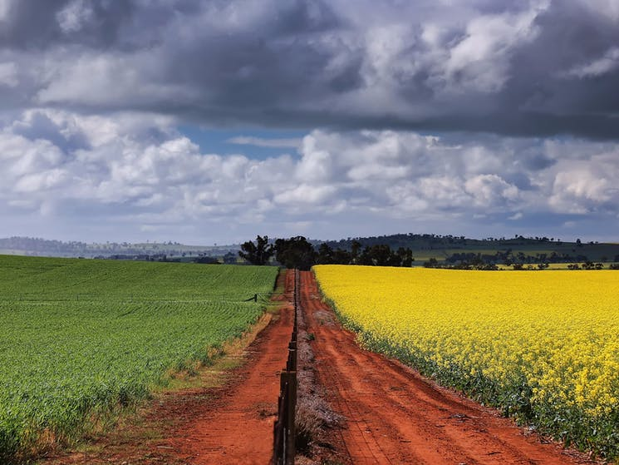

March 2026
DRAFT POLICY POSITIONS
Climate uncertainty
Policy Position Statement: Climate Uncertainty
NIC Policy Positions are agreed with Members and prepared in conjunction with our Guiding Policy Principles.

- Risks of climate change and uncertainty are shared-risks. Governments, communities, industry, irrigators, and the environment must collectively plan and prepare to operate under an increasingly variable climate with a focus on achieving more from less.

- Water security for farming is important, particularly with a changing climate, and must also be a priority in efforts to improve water security alongside other users. With current water allocation systems, farmers are increasingly vulnerable to climatic extremes.
- Farmers continually adapt to changing climatic conditions to remain productive, sustainable, and globally competitive. Ongoing investment in water-use efficiency, research and development, and fit for purpose infrastructure will be essential to ensure Australian farmers can continue to do more with less and remain world leaders. However, we can only adapt to a point.

- Australia’s contemporary water management framework is designed to respond to climate variability through allocation systems that reflect water availability. These systems prioritise water to critical needs such as town water supplies, and the environment for rivers to flow.

- Water markets play a key role in enabling entitlement holders to manage risk, optimise water use, and respond flexibly to changing conditions.

- Irrigation infrastructure is a vital climate adaptation and mitigation tool, allowing water to be captured, stored, and used efficiently over time. Ensuring water infrastructure is modern, resilient, and fit-for-purpose under future climate scenarios is essential to maintaining water security for all.

Guiding Policy Principles
All NIC Policy Positions are guided by 4 overarching Policy Principles:
- Enhance and protect water property rights without altering the characteristics.
- Utilise market mechanisms to ensure no negative third-party impacts on water reliability or availability; compensate or mitigate any impacts by negotiation with affected parties.
- Governments must effectively engage industry in policy development and implementation.
- Fair and equitable policy must share risks and opportunities among all stakeholders not just water users, ensuring a balance.

Background
Linked NIC Position Statements
- Water Reliability

Policy settings
Climate change (and climate variability) is factored into water sharing and management frameworks, through a number of mechanisms most commonly applied by the allocation decision making framework of individual states. Collectively, we can call these ‘Automatic Climate Response Mechanisms’. As water is managed by the States, these mechanisms are primarily embedded in State legislation and policies. These include:
- States’ water sharing policies and practices account for climate variability, and represent that jurisdictions assessment of risk and thus climate change.
- This includes via the making of water allocations, and in setting extraction limits.
- Data shows that consumptive water users receive less water during droughts (as well as HEW), with water allocations returning with water availability.
It is not well appreciated that current policy settings do factor in climate. This is not to say that the system is foolproof, rather, to ensure an accurate information base of possible future scenarios (not just of water availability, but how this trickles down through water sharing frameworks to produce different outcomes for different users). NIC is concerned by a view that the Basin Plan and water management do not consider climate change – this is not correct.
Climate change planning must also focus on water security for critical human needs (including First Nations), and water security for agriculture. Even under the most extreme climate scenarios, it will be important to maintain a viable agricultural sector. Under current management arrangements, where water allocations to consumptive users are lowest-priority, the irrigated agricultural sector will be hit first and hardest. This does present risk to water users.
Managing for climate change should not about demanding more water to maintain historical benchmarks to a changing environment. All users must share risks and opportunities. NIC agrees with the questions in the MDBA’s Early Insights Paper that:
“can these [achievement of Basin Plan environmental outcomes] be better mitigated and responded to, or will some desired environmental outcomes not be sustainable under climate change?”
Data
When referring to ‘plausible climate futures’, this must include both wetter and drier periods, as well as acknowledge the uncertainty in projections. There is a tendency for focus to only be on the drier.
Whilst climate risk assessments were undertaken on a national and Basin scales. The approaches did not provide clear indication of the likely reliability impacts and highlighted the significant uncertainty. More work must be undertaken to include modelling of what water allocations for agriculture will look like under these various climate scenarios (including availability and affordability), and what this will mean for the industry. This will be important to: (i) understand the status quo; and (ii) determine if interventions (of some form) are necessary to improve water security for agriculture, to maintain production into the future. Indeed, the water security limitations on Australian agriculture are a vital piece of information for Governments to ensure domestic food security and food sovereignty, as well as to maintain a strong export base.

Mitigation
In our view, a more comprehensive look at a range of solutions, including infrastructure is needed to secure water for critical needs (such as towns) but also agriculture. This will need a broader support for practical solutions, aligned to the risk and could include considerations of new or smarter infrastructure (storage dams, weirs, pipelines, tanks), secondary supply sources for towns and/or industrial users, improved water recycling, desalination, or water-carting as a last resort for town water supply. This will require working with in partnership with those impacted, understanding acceptable risk and opportunity. For town water supply this include residents and local councils, who are primarily responsible for town water supply.
Farmers must adapt to climate to remain viable businesses. However, there will be limits on pace and scale of adaption available, which can be improved through smart research and development and awareness. However, the agricultural industry cannot be expected to burden all of climate change risks and impacts alone.

