Submission
NIC
July 2026
Submission


NIC Submission to “Strong Voices, Healthy Waters: upholding Aboriginal and Torres Strait Islander peoples’ water rights through the review of the Water Act 2007”
DRAFT - Water Act Review

Purpose
The National Irrigators’ Council (NIC) provides this submission in response to the public consultation on the document “Strong Voices, Healthy Waters: upholding Aboriginal and Torres Strait Islander peoples’ water rights through the review of the Water Act 2007”, published by DCCEEW in May 2026. This forms part of the broader statutory review of the Water Act 2007.
NIC understands that submissions provided to the Basin Plan Review public consultation process will automatically be submitted to the Water Act Review, and refers to the comprehensive bodies of work completed by NIC:
- National Irrigators' Council - 'Moving Forward' Our Review of the Murray Darling Basin Plan
- National Irrigators' Council - Discussion Paper Submission
NIC notes that public consultation on a broader range of topic areas will also be occurring in July-August and November this year, to which NIC will be participating.
In accordance with section 253 of the Act:
The review must also identify opportunities under this Act to promote the principles set out in the United Nations Declaration on the Rights of Indigenous Peoples, being the Resolution adopted by the General Assembly of the United Nations on 13 September 2007.
This submission seeks to directly provide input to this statutory requirement.

Overview
Key points raised in this submission include:
- NIC acknowledges the traditional owners of country; their deep connection with land and water, and the strong spiritual obligation of Aboriginal people to care for country.
- NIC supports the use, access and management of water for Cultural objectives, within the current water management framework.
- NIC is concerned that the public consultation documents to date are very high-level – for example, they do not identify current arrangements for Indigenous rights at both a State and Commonwealth level, which may lead to a poor understanding of the status quo, issues and opportunities. They also do not explore what is being proposed in a practical sense, making it challenging for stakeholders to provide comment.
- NIC appreciates the technical complexity of the water management framework and calls on this review to provide the appropriate technical resources to ensure the findings are factually accurate and reflective of this framework. Some of the statements in the materials to date are incorrect.
- The role and scope of the Water Act 2007 (Cth) within Australia’s Constitution must be considered to determine the legislative capabilities to address many of the issues raised given water remains managed by the States. This is not to belittle any issues raised, rather, to ensure expectations do not exceed what this instrument can deliver. For this reason, it is important for the review to explore both statutory and non-statutory pathways, as a collective government approach to promoting the principles of UNDRIP will be important (not just within one element the Water Act).
- Any legislative amendments being contemplated must be done so in a manner that is consistent with the current NWI water management framework.
- There must be no third-party impacts on current water entitlements, their reliability, nor any legal or practical changes to entitlement characteristics, from any initiative or program - including Cultural and environmental flows.
- Any legislative amendments being considered to give effect to a renewed NWI / NWA can only occur after the agreement of the States and Territories has been obtained, to continue the critically important legacy of state cooperation. The focus of the renewed NWA on First Nations water is particularly relevant, including the feedback provided across stakeholders and state governments to DCCEEW on the most recent publicly-available version.

Recommendations

Recommendations
<insert final recommendations>

About us
The National Irrigators’ Council (NIC) is the peak industry body for irrigated agriculture in Australia. NIC is the voice of irrigation entitlement holders, water delivery operators and industries involved in food and fibre production.
Contents
Purpose 2
Overview 2
Recommendations 3
About us 3
Submission 5
Water reform framework must be adhered to 5
National Water Agreement 6
The role of the Water Act 2007 (Cth) given state powers 6
Current status of indigenous water rights 7
Indigenous water rights and interests at the Commonwealth level 7
Indigenous water rights and interests at the State level 9
Need for a solutions-focus 11
Clarification of key terms is crucial 12
Issues beyond water management 12
Recognising the diversity of Indigenous interests 13
Exploring Synergies 14
Cultural and environmental 14
Cultural and socio-economic 14
Building on successes 15
Entitlements 16
Clarifying the baseline 16
Aboriginal Water Entitlements Program 17
Decision-making 20
Conclusion 20
Contact 21

Submission
Collaboration not separation
NIC acknowledge the traditional owners of country; their deep connection with land and water, and the strong spiritual obligation of Aboriginal people to care for country.
NIC supports, recognises and values Cultural objectives in water planning and management.
NIC supports the use, access and management of water for Cultural objectives, within the current water management framework and market systems.
By working together, we believe better outcomes are possible. We believe there are ways forward that can realise real, practical, and meaningful outcomes for First Nations peoples in our communities – without creating tensions or divisions. We are proud of the positive relationships our sector has with First Nations.
NIC seeks to engage in this process in a constructive, respectful and informed manner. We offer our knowledge and expertise of the water management and planning frameworks, to look for opportunities to create mutually-agreeable ways forward.
NIC notes the positive examples of our sector working with First Nations in our communities to advance outcomes and seeks that this process expands on that collaborative and constructive basis, rather than attempting to create divides amongst stakeholders. A process based on including all stakeholders, recognising a willingness for practical outcomes, and shared understandings, will enable working together to achieve meaningful outcomes with shared support.
NIC is deeply concerned by divisive approaches to this matter, that seek to create tensions between stakeholders. NIC is not entertaining such division.

Water reform framework must be adhered to
Water reform in Australia has faced three-decades of reform. The blueprint for this reform journey was the National Water Initiative (NWI), which laid the foundations for the key regulatory instruments and approaches – such as sustainable extraction limits, water entitlements separate to land and allocation systems that provide a share of the available resource, all detailed within all detailed within statutory water plans – to name a few. These regulatory tools are now broadly established around Australia, with multiple iterations in place in regions like the Murray Darling Basin. This has given governments the ability to manage and control water as a distinct resource, recover water if deemed non-sustainable, and impose responsibilities.
Any future reform must consistently work with this foundational blueprint.
Key positions:
- NIC supports the use, access and management of water for Cultural objectives, within the current water management framework and market systems.
- There must be no third-party impacts on current water entitlements, their reliability, nor any legal or practical changes to entitlement characteristics, from any initiative or program - including Cultural and environmental flows.
NIC recommend that:
- Any legislative amendments being contemplated are done so in a manner that is consistent with the current NWI water management framework (i.e. water entitlement framework, as per the NWI characteristics); which necessarily involves no third-party impacts on current water entitlements, their reliability, nor any legal or practical changes to entitlement characteristics.

National Water Agreement
NIC also notes that the NWI is currently being renewed into a new National Water Agreement (NWA). At this point in time, there has been no transparency to stakeholders on the final version, and it is understood that many states have not signed the new version (only the Commonwealth Minister). If this review seeks to incorporate those new articles of the NWA into legislation, it will be critical to first ensure that the state jurisdictions are supportive (i.e. that they become signatories) in order to maintain the same cooperative foundations (which will almost certainly require proper process to ensure transparency of the final version), and that this process takes place prior to legislative amendments. Put simply – it is not a National Water Agreement, if no states have agreed – and it would be premature to rely on it for this review, or progress to legislative amendments, without such agreement. Put simply – it is not a National Water Agreement, if no states have agreed – and it would be premature to rely on it for this review, or progress to legislative amendments, without such agreement.
The public consultation on the drafting of the NWA included themes relevant to First Nations. To the extent that this review looks to those NWA articles, it will be important for this review to incorporate the learnings and feedback from that process also. At this point, many of the issues raised by stakeholders during that NWA process are not reflected in the consultation materials. NIC recommends this review also considers the submissions provided by a broad range of stakeholders relating to those themes in the NWA.
NIC recommend that:
- The final version of the NWA is published for transparency, to inform this public consultation.
- Any legislative amendments or review recommendations intended to give effect to a renewed NWI / NWA only occur after the agreement of the States and Territories has been obtained, to continue the critically important legacy of state cooperation.

The role of the Water Act 2007 (Cth) given state powers
The regulatory architecture for water management is complex, and the role of the Water Act 2007, and the Australian Government more broadly, must be considered in this review. A proper understanding of this regulatory architecture is needed to inform an understanding of the status quo, identify the challenges and opportunities, and possible ways forward.
A complexity for this review is that the Water Act 2007 (Cth) is the federal legislation, whereas water is managed by the States (as per the Australian Constitution). Where ‘water rights’ are being considered - the relevant instruments to give effect to Aboriginal rights and interests would typical fall mostly within state legislation and instruments. It would not be typical for the Water Act 2007 (Cth) to be the instrument to create statutory rights – similarly – rights of water access for irrigation are issued by the States.
Looking at only federal instruments – for a portfolio which is fundamentally managed by the States – will fail to recognise the current landscape.
NIC recommend that as part of further consultation:
- The scope and role of the Water Act 2007 in this domain is clearly identified, specifically, what is within scope of Commonwealth legislation, and that of state legislation and regulations.
In assessing scope, it will also be important to look at the role of legislation, versus non-statutory approaches. Many of the issues raised appear to be not necessarily those requiring a legislative solution – rather improved delivery on existing legislation, improvements or expansion of programs, increased funding to programs, or greater involvement.
NIC recommend that as part of further consultation:
- The role of both legislative and non-legislative pathways forward is explored.

Status of indigenous water rights
NIC was disappointed to see the Discussion Paper failed to accurately describe the status and nature of Indigenous rights to water. This is not to say that there is no space for improvements, rather, that any change must be built on an evidence-based and factual understanding of the status quo, and an accurately identified problem-definition.
The Discussion Paper says: “When the Water Act was developed, it did not take into account Aboriginal and Torres Strait Islander peoples’ water rights or interests in the management of water.” This is not correct.
In our understanding, the issue is not that the legislation does not take this into account, it is:
- The primary instruments to give effect to Aboriginal rights and interests in water is mostly within State legislation and instruments – as water is managed by States (as per the Australian Constitution), and any rights or entitlements (to any party) are issued by the States;
- There has not been the same degree of investment in programs to deliver upon or implement the objects of the legislation – for example, as a case study, focus of the multi-billion dollar Basin Plan has been recovering water volumes from the consumptive pool for the Commonwealth Environmental Water Holder (CEWH), with a significantly lesser focus on targeted cultural programs (they have existed but to a much lesser extent, and only recently increased in focus). This reflects the focus of that period of reform being the issue of sustainability;
- There have been several challenges with established First Nations representative / governance arrangements and models which has understandably led to dissatisfaction (as explored later).
It is appreciated that many First Nations peoples feel implementation has not addressed their rights or interests – these points are not to dismiss that – rather, to emphasise that properly understanding the status quo is critical to moving forwards in a way that realises actual improvements.
The below section seeks to capture some (not all), of the current arrangements – at both a commonwealth and state level – to assist in reflecting this status quo.

Indigenous water rights and interests at the Commonwealth level
This section outlines some of the current arrangements in place at a Commonwealth level.
National Water Initiative
25 “The Parties agree that, once initiated, their water access entitlements and planning frameworks will: … recognise indigenous needs in relation to water access and management”.
Indigenous Access
52. The Parties will provide for indigenous access to water resources, in accordance with relevant Commonwealth, State and Territory legislation, through planning processes that ensure: i) ii) inclusion of indigenous representation in water planning wherever possible; and water plans will incorporate indigenous social, spiritual and customary objectives and strategies for achieving these objectives wherever they can be developed.
53. Water planning processes will take account of the possible existence of native title rights to water in the catchment or aquifer area. The Parties note that plans may need to allocate water to native title holders following the recognition of native title rights in water under the Commonwealth Native Title Act 1993.
54. Water allocated to native title holders for traditional cultural purposes will be accounted for.

Water Act 2007 (Cth)
(fa) to ensure that the use and management of Basin water resources takes into account spiritual, cultural, environmental, social and economic matters relevant to Indigenous people, including in relation to their knowledge, values, uses, traditions and customs; and
Subdivision B (2) (da) the use and management of Basin water resources that takes into account spiritual, cultural, environmental, social and economic matters relevant to Indigenous people;

The BCC also requires at least 2 Indigenous persons with expertise in Indigenous matters relevant to the Basin’s water resources.

There are further provisions in the Basin Plan and Water Resource Plans.
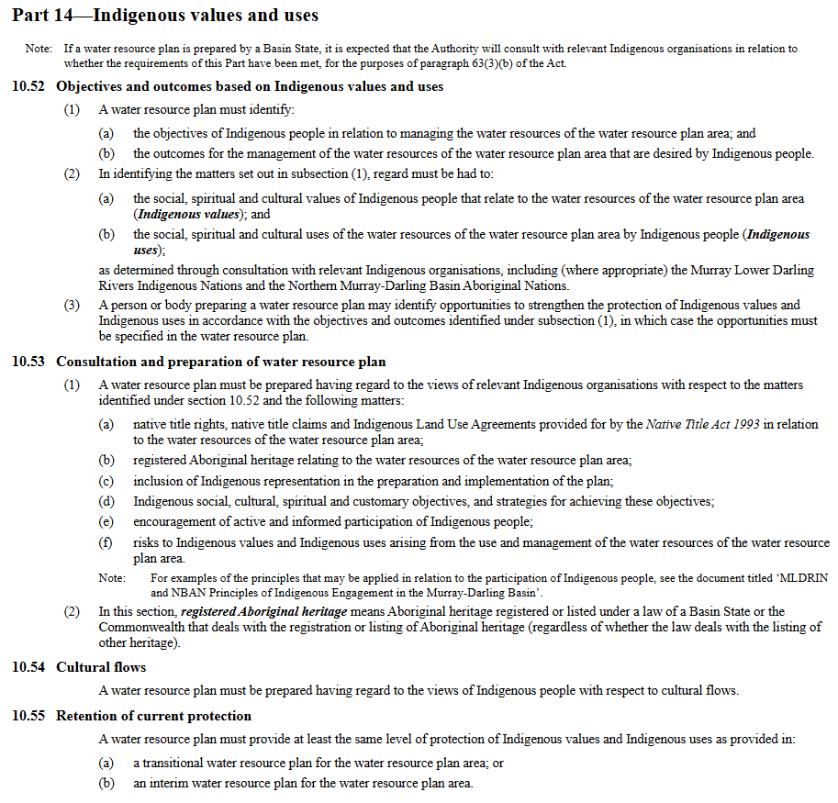

Indigenous water rights and interests at the State level
This section outlines some of the current arrangements in place at a State level. This varies between jurisdictions. NSW is used below as a case study.
In the NSW Water Management Act 2000:
3 – Objects
(c) to recognise and foster the significant social and economic benefits to the State that result from the sustainable and efficient use of water, including—
(i) benefits to the environment, and
(ii) benefits to urban communities, agriculture, fisheries, industry and recreation, and
(iii) benefits to culture and heritage, and
(iv) benefits to the Aboriginal people in relation to their spiritual, social, customary and economic use of land and water,

Native titles rights are also established:
Division 3 Native title rights
55 Native title rights
(1) A native title holder is entitled, without the need for an access licence, water supply work approval or water use approval, to take and use water in the exercise of native title rights.
(2) This section does not authorise a native title holder—
(a) to construct a dam or water bore without a water supply work approval, or
(b) to construct or use a water supply work otherwise than on land that he or she owns.
(3) The maximum amount of water that can be taken or used by a native title holder in any one year for domestic and traditional purposes is the amount prescribed by the regulations.
** native title rights means non-exclusive rights to take and use water for personal, domestic and non-commercial communal purposes (including the purposes of drinking, food preparation, washing, manufacturing traditional artefacts, watering domestic gardens, hunting, fishing and gathering and recreation, cultural and ceremonial purposes).

These rights and objectives are further explored via Water Sharing Plans (WSPs). For example, below is a case study from the Water Sharing Plan for the New South Wales Murray and Lower Darling Regulated Rivers Water Sources 2016:
10 Aboriginal cultural objectives
(1) The broad Aboriginal cultural objective of this Plan is to maintain, and where possible improve, the spiritual, social, customary and economic values and uses of water by Aboriginal people.
(2) The targeted Aboriginal cultural objectives of this Plan are as follows—
(a) to provide access to water in the exercise of native title rights,
(b) to provide access to water for Aboriginal cultural use,
(c) to protect and, where possible enhance, identified water-dependent culturally significant areas, including important riparian vegetation communities,
(d) to maintain water quality within target ranges to ensure suitability of water for Aboriginal cultural use.
(3) The strategies for achieving the Aboriginal cultural objectives of this Plan are as follows—
(a) manage access to water consistent with the exercise of native title rights,
(b) provide for water associated with Aboriginal cultural values and uses,
Note. The provisions in Part 7 provide opportunities for Aboriginal people to access water by allowing for the granting of an access licence of the subcategory “Aboriginal cultural”.
(c) reserve a share of water to partially mitigate alterations to natural flow regimes in the water sources,
Note. The provisions in Division 1 and 2 of Part 10 partially mitigate alterations to natural flow regimes.
(d) reserve a share of water to maintain longitudinal and lateral connectivity within and between water sources.

(4) The performance indicator used to measure the success of the strategies for achieving the broad Aboriginal cultural objective in subclause (1) is an evaluation of the extent to which the combined outcomes of the targeted Aboriginal cultural objectives in subclause (2) have contributed to achieving the broad objective.

(5) The performance indicators used to measure the success of the strategies for achieving the targeted Aboriginal cultural objectives in subclause (2) are the changes or trends in Aboriginal cultural benefits during the term of this Plan as assessed using one or more of the following—
(a) the use of water by Aboriginal people by measuring factors including—
(i) the extent to which native title rights are able to be exercised, consistently with any
determination of native title or indigenous land use agreement, and
(ii) the extent to which access to water has contributed to achieving Aboriginal cultural
outcomes,
(b) the recorded range or extent of target populations of native fish,
(c) the recorded range or condition of target populations of riparian vegetation,
(d) the recorded values of water quality measurements including salinity, harmful algal blooms, total nitrogen, total phosphorus, pH, water temperature and dissolved oxygen.

(6) In evaluating the effectiveness of the strategies in meeting the objectives of this clause, the following will be relevant—
(a) the extent to which the strategies in subclause (3) and provisions in this Plan have been implemented and complied with,
(b) the extent to which changes in the performance indicators can be attributed to the strategies in subclause (3) and provisions in this Plan,
(c) the extent to which the strategies in subclause (3) support achievement of the Aboriginal cultural objectives,
(d) the water made available for Aboriginal cultural values and uses during the term of this Plan through available water determinations and the granting of new access licences,
(e) the extent to which external influences on surface water-dependent Aboriginal cultural activities during the term of this Plan have affected progress towards achieving the Aboriginal cultural objectives.

This includes the ability for the Minister to grant access licences for Aboriginal cultural purposes.
41 Specific purpose access licences

(2) A person may make an application for a regulated river (high security) (Aboriginal cultural) access licence only if the share component of the proposed access licence is no greater than 10 ML/year.

(3) The Minister may only grant a regulated river (high security) (Aboriginal cultural) access
licence if—
(a) the licence is primarily for the taking of water by an Aboriginal person or Aboriginal
community for personal, domestic or communal purposes, including the following—
(i) drinking and food preparation,
(ii) washing,
(iii) manufacturing traditional artefacts,
(iv) watering domestic gardens,
(v) cultural teaching,
(vi) hunting, fishing and gathering,
(vii) traditional food production
(viii) purposes to achieve environmental outcomes,
(ix) recreational, cultural and ceremonial purposes, and

These Aboriginal cultural licences receive a 100% water allocation, making them one of the highest security water licences. It is acknowledged that the processes for seeking these licences have been challenging.
This is not to say that no change is needed – evidently First Nations people are not satisfied by current arrangements. However, a proper understanding of the status quo is crucial to identify the right problem-definition and thus ways forward.
NIC recommend that as part of further consultation:
- The current rights and arrangements across instruments (State and Federal) are comprehensively documented in consultation materials;
- The specific issues with the status quo are documented (such as processes being timely or difficult to navigate, the ongoing expenses of entitlements, etc) to ensure the right problem-definition is established.

Need for a solutions-focus
NIC emphasises the importance of further consultation materials articulating what the nature of proposed solutions are for the issues raised. This will be essential for all stakeholders to provide comment.
For example, the consultation materials say:
“The Water Act does not clearly reflect key principles from the UNDRIP, such as self-determination and Free, Prior and Informed Consent.”
“Aboriginal and Torres Strait Islander peoples are seeking a more complete and connected approach to water–one that:
• Recognises rights and self-determination.
• Respects Free, Prior and Informed Consent in decisions affecting water and Country.
• Acknowledges Cultural, social, spiritual, economic and environmental values.
• Acknowledges the deep connections between land, water, sky and wellbeing.”
Further information is required on what this is intended to look like in a practical sense, ‘how’ this is proposed to occur, and what the pathway forward is intended to be.

Clarification of key terms is crucial
NIC is concerned that there are varying interpretations of key terms, which risks varied expectations of what changes are being sought and/or agreed to. As part of further public consultation, it will be important to provide definitions and explanations of what these terms mean in the context of water management in Australia, what they include and do not include within scope in a practical sense, and where applicable, have those definitions included in relevant instruments. This will ensure all stakeholders, and decision-makers, are on the same level of understanding – in both the public consultation phase, but also, in the legislation and implementation phase.
This is particularly relevant if the definition of the term in this context is different to what a common or dictionary definition of that term may be. For example, the phrase ‘consent’ in many contexts would mean a veto power, however, we have been informed that this is not what is intended here.
Key terms which NIC believes require formal definitions to describe in practical terms what these terms mean and do not mean, as part of further consultations:
- Consent – in the context of free, prior and informed consent
- Authority
- Water rights
- Living Entity
- Self-determination
NIC recommend that:
- Further public consultation includes definitions to clarify key terms (particularly, consent and self-determination) within the context of water management and the proposed arrangements being sought.

Issues beyond water management
It must be noted that UNDRIP is a comprehensive international instrument that goes beyond the scope of just water resource management.
While it provides guidance for considering Indigenous rights to water (amongst other things) its full and effective implementation sparks a broader set of constitutional, institutional, and governance considerations and processes. For this reason, we encourage a broader, whole of Government discussion on how UNDRIP can be considered and reflected rather than the focus here within only the Water Act.
A key challenge in identifying opportunities to promote UNDRIP within the Water Act is that the realisation of many of its articles may require systemic reforms that extend beyond the scope of a single portfolio. While portfolio-specific legislation such as the Water Act can play an important role in promoting some articles, it operates within a wider institutional framework that ultimately shapes how the legislation is operated and implemented.
These matters necessarily involve complex, whole-of-government considerations and, if constitutional change is contemplated, established democratic processes such as referendum and broad public engagement across all Australian communities. Consideration of UNDRIP in isolation from these broader governance settings may risk creating expectations that exceed the practical or legal capacity of individual statutory instruments and may also lead to fragmented or inconsistent policy outcomes, and poor public acceptance.
Recent efforts to progress certain aspects of constitutional or structural reform relating to Indigenous recognition have not been successful at referendum. This historical context shows the importance of carefully considering both the scope and sequencing of reform, as well as ensuring that any proposals are developed through inclusive and durable processes that have broad public legitimacy.
For the avoidance of doubt, we are not noting this to frustrate the process – rather – to note a very legitimate challenge in terms of progressing Indigenous rights at a portfolio level, in the absence of broader institutions and structures. This is not intended to detract from or diminish the importance of advancing Indigenous rights and interests. Rather, it highlights the complexity involved in translating international declarations such as UNDRIP into domestic law and policy at the portfolio level, in the absence of overarching reforms across the broader governance system.
It is noted that in the preamble of UNDRIP, it says:
“The provisions set forth in this Declaration shall be interpreted in accordance with the principles of justice, democracy, respect for human rights, equality, non-discrimination, good governance and good faith.”
“Recognizing that the situation of indigenous peoples varies from region to region and from country to country and that the significance of national and regional particularities and various historical and cultural backgrounds should be taken into consideration…”
Again, for the avoidance of doubt, this is no reason to not promote UNDRIP in legislation. Rather, it reflects the practical challenges in doing so, and need for careful and well-considered mechanisms, sequencing of reforms and public engagement. Failure to do so may risk delivering only tokenistic change that does not meet the expectations of First Nations peoples, or reform that is not accepted or supported by broader democratic institutions.
NIC recommend that:
- The review seeks to discern what falls within the scope of the water portfolio, and what requires much broader reform, to properly address.
- A transparent whole of Government approach should be enabled, rather than individual agencies, legislation or areas of Government to be considered and consistent.

Recognising the diversity of Indigenous interests
It is important to acknowledge in this process the diversity of Indigenous interests.
As the Basin Plan legislation notes: “Indigenous use includes for cultural, social, environmental, spiritual and economic purposes.”
There is likely not one solution to address all these areas – rather – various tools to promote better outcomes across these areas.
It is also appreciated that Indigenous views are not homogenous, as per any population, and understanding the diversity of perspectives is important.
NIC recommend that:
- Further public consultation seeks to identify specific targeted measures to address the diverse range of objectives sought.

Exploring Synergies

Cultural and environmental
It is recognised that cultural and environmental objectives are unique. However, there are also many synergies in these objectives, where programs and measures can deliver co-benefits.
NIC supports inclusive processes and partnerships that explore synergies between environmental, socio-economic, critical human needs and Cultural objectives to optimise outcomes for all.
It is noted that the First Nations Environmental Water Guidance Project was established in 2019-20. The MDBA says:
“water for the environment, aimed at improving river health, can also provide tangible benefits for First Nations people”.
“Through this project NBAN and MLDRIN worked with First Nations to develop environmental watering objectives that describe tangible benefits experienced by First Nations people from the delivery of environmental water on Country.”
“This traditional ecological knowledge was used to develop the Basin-wide annual environmental watering priorities.”
The outcomes that are being achieved via the delivery of HEW (and PEW) on Country are important to identify, as well as what other supporting measures could further outcomes (such as Caring for Country programs, and complementary measures).
There is also the National Cultural Flows Research Project which provides information on cultural flows, including identification of both unique and shared objectives with environmental water.

Cultural and socio-economic
NIC agree with the statement in the independent assessment of social and economic conditions in the Murray–Darling Basin:
“Our hearts sink when we observe the current circumstances of First Nations peoples in the Basin and we call for urgent change to improve their social and economic circumstances.”
It will be important to recognise the intersections between cultural and socio-economic outcomes too, which includes the role of water for production (i.e. irrigated agriculture) to provide an economic base for rural communities, both Indigenous and non-Indigenous. The social and economic benefits from irrigated agriculture span from increased employment to increased service access such as healthcare and education.
The impacts from water reforms that seeks to remove water from production have seldom explored this reality of the impacts across all sectors of the community.
The Bourke Shire Council – a community with a relatively large Indigenous population - has said:
“The township of Bourke, and the surrounding Shire, is a community in the Basin that has been significantly impacted because of the implementation of the surface water diversions Cap (the Cap) and from the water buy back. It has been estimated that up to 60% of the local economy has been impacted as a result of the implementation of the Cap process with a further 10% of the economy impacted through the water buyback process. Both these processes have resulted in both economic and social reduction.”
“Furthermore, after enduring further wealth loss through buybacks, the Bourke community stands to lose further social capital with the current Bridging the Gap voluntary buyback.
A further permanent reduction in water is likely to permanently constrain any economic and social recovery of Bourke and entrench and significantly worsen existing high levels of social disadvantage, particularly among its large indigenous population.”
It will be important for the review to capture this synergy, on the role of irrigated agriculture and water for production, for rural social and economic outcomes which includes Indigenous outcomes.
NIC recommend that:
- Public consultation materials must do a better job of clarifying specifically what cultural outcomes are being sought – and how these can be achieved;
- Opportunities for synergies and co-benefit outcomes need to be identified, rather than a purely siloed approach.

Building on successes
There are many positive examples of First Nations Partnerships and successes, across the Basin and Australia, which show what is possible. This includes the Living Murray Indigenous Partnerships Program as well as projects such as Gayini Nimmie-Caira Project, and many others.
The MDBA has collated ‘Stories of First Nations delivering benefits to Country and communities’ with an extensive collection of examples now published.
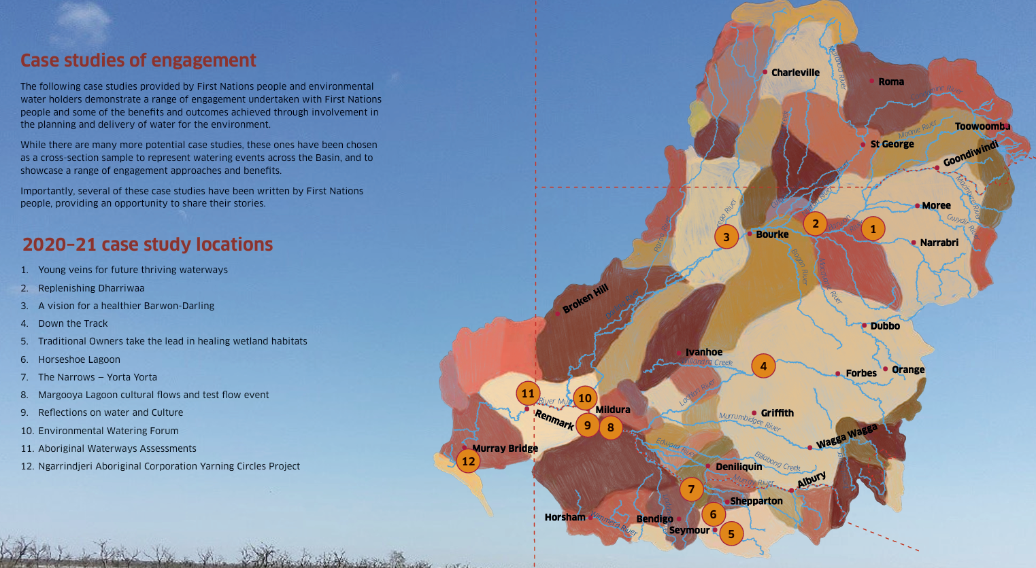
The ‘Rivers, the veins of our Country’ report says:
“Across all jurisdictions there are current examples of First Nations people influencing or participating in all stages of environmental water management, which would not have been the case ten or even five years ago.”
It will be important to share these positive successes as part of this review, as well as lessons learnt.
NIC recommend that:
- Public consultation materials also show the positive successes, including effective partnerships programs.

Entitlements

Clarifying the baseline
There is a figure claimed of 0.2% of water entitlements are owned by First Nations. This is queried.
Further work is required to validate that statistic before heavily relying upon it. For example, methodological concerns (as largely acknowledged by the authors of the statistic) include:
- This statistic is “focused on water held by Indigenous organisations and entities, referred to here as ‘Indigenous holdings’ because data on the water holdings of individuals identifying as Indigenous is not readily available”. Put simply, this does not include water held by people who identify as Indigenous – as most states do not collect information on if the owner identifies as Aboriginal or not.
- The statistic: “focused only on water entitlements, which are issued by State and Territory Governments and grant holders’ permission to take, extract and use water from a specified surface water source (e.g. rivers and creeks) or groundwater source (e.g. aquifers). We did not consider other statutory rights to access water that do not require an entitlement, including water use rights associated with land occupation such as stock and domestic basic rights and native title rights”. Put simply, this does not include major forms of water rights for First Nations, such as Native Title Rights.
- Does not include water that is managed for multiple purposes, such as entitlements owned by the CEWH or state environmental water holders and used to serve multiple objectives including cultural objectives identified in Long Term Water Plans.
- Does not include the broader management of the resource, including in the use and management of Planned Environmental Water (PEW) which (name aside) is the large volume of water above extraction limits (i.e. not on a water entitlement) that is managed for various uses as identified in each Water Sharing Plan, which includes cultural objectives.
- Does not include temporary trading of water.
NIC is concerned that DCCEEW is making statements on their website, such as: “First Nations People hold rights to about 40% of Australian land through native title. Yet, First Nations Peoples own less than 0.2 percent of surface water entitlements” when the authors specifically point out that they exclude Native Title from their methodology, so this is not a comprehensive, nor equal, comparison. We are concerned that this has created a misleading, and skewed focus, more reflective of a political agenda - and removed from many of the cultural objectives being sought by First Nations people.
This aside, it is cautioned to focus too heavily on water entitlement ownership, as that siloed approach is unlikely to serve the broader and diverse outcomes being sought by First Nations people. Is the ‘ownership’ of a water entitlement the necessary or most appropriate vehicle to achieve the desired objectives?
NIC is concerned that there is a narrow focus on only water access entitlements. We are concerned that this singular lever will not lead to the realisation of broader cultural objectives sought, and in turn, creates further barriers.
NIC recommend that:
- The review critically analyses whether the proportion of water entitlement ownership by First Nations is the right indicator to focus on, or what other indicators may better reflect the outcomes being sought by First Nations peoples.
- The review undertakes fact-checking on the statistics being published by DCCEEW as part of the review – or at least - provides crucial methodological context.

Aboriginal Water Entitlements Program
In 2024 the Australian Government progressed its Aboriginal Water Entitlements Program (AWEP), releasing the Strategic Purchasing Framework for the program with its increased budget of $100 million (increased in late 2023 from $40 million). The programs focus is the Murray Darling Basin with a prioritization of location and entitlements provided in Table 1 and Table 2, with the following program objectives:
- Acquire surface water entitlements to enhance water security for Basin First Nations Peoples.
- Ensure purchases align with the principle of connectivity, underpinned by wealth generation.
- Achieve value for money for Basin First Nations Peoples and the Australian Government.
- Maintain high standards of probity, transparency, and accountability.

The AWEP is aimed at contributing to the National Closing the Gap strategy and targets. Currently there is no specific volumetric national inland waters target, each jurisdiction plans to establish their own.

NIC strongly supported that:
“All water entitlements purchased through the program will remain in the consumptive pool. Entitlement characteristics will not change with a change of ownership.”

This is a key part of respecting the NWI-style water framework.

Interim governance arrangements were established with targeted purchases towards the program beginning in 2025. The outcome of these purchases is unknown, but extracts from the Strategic Purchasing Framework are below.

Table 1: Priority 1 for the Strategic Purchasing Framework for AWEP
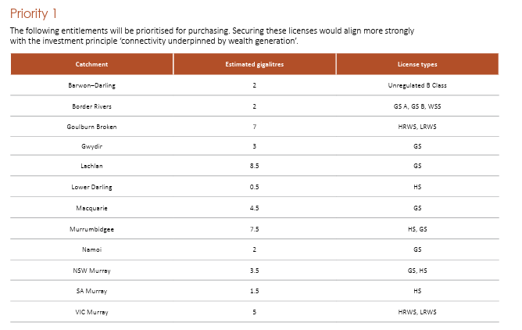

Table 2: Priority 2 for the Strategic Purchasing Framework for AWEP
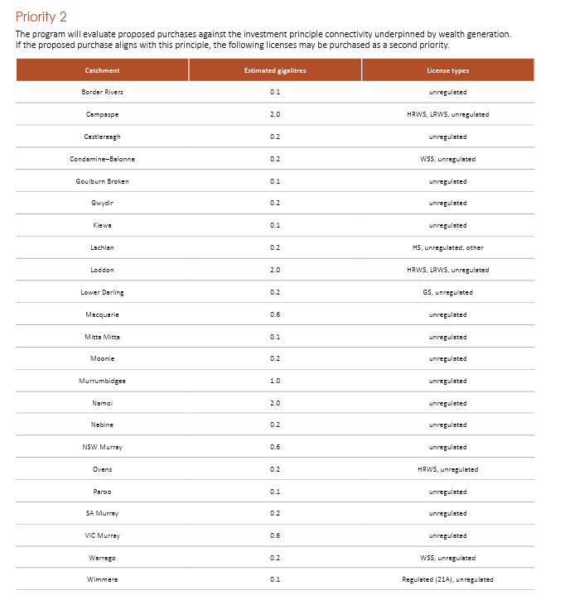

Temporary trade
NIC supports the approach of looking at temporary trading opportunities.
Temporary water trading allows the use of water entitlements in a flexible way, to respond to opportunities that arise through seasonal water availability, market prices and demands.
Governance
NIC is of the position that enduring, transparent and accountable governance frameworks must be in place prior to use of public funds to purchase entitlements for any purpose - including Cultural or environmental.
At this point in time, interim governance arrangements have been established, and enduring water holding arrangements are under development. It is understood that interim arrangements include an advisory group and a directorate.
In terms of enduring arrangements, NIC notes that:
“Based on the outcomes and benefits identified by Basin First Nations through extensive co-design, a Charitable Trust has been identified as the proposed model. The Government will continue to work with Basin First Nations Peoples to co-design the Charitable Trust.”
NIC is concerned by the direction of these governance arrangements, for the reasons identified in the interim report of draft governance models. For example:
“A private trust model, while independent of government, would lack the accountability and transparency mechanisms built into the statutory trust model and make it harder for individuals to raise concerns and obtain government review or action. For an individual Basin First Nation or First Nation Person, it could be difficult to enforce the terms of the Trust Deed. This could be managed to some extent by nominating appointors in the Trust Deed – however, there would never be the broad rights available in the statutory trust model.”
Appropriate governance arrangements, particularly where public funds are involved, where there is an objective of wealth transfer, and likely strategic commercial opportunities being sought, is critical to get right. There must be robust oversight and audit mechanisms in place, including with skill in technical water matters.
NIC recommend that:
- Further work is required to ensure appropriate governance arrangements, to ensure realisation of objectives, and accountability for proper use of public funds.

Decision-making
NIC notes the Northern Basin Aboriginal Nations (NBAN) and Murray Lower-Darling Indigenous Nations (MLDRIN) were established to address many of the issues raised in the Discussion Paper.
As part of the public consultation, and the issues raised, it will be important to evaluate these models’ effectiveness.
NIC notes that NBAN, for example, was recently disbanded, with the MDBA saying:
“In recent times, NBAN has been unable to deliver on its contractual commitments, and we are now in the process of finalising these arrangements.”
It is understood further work has since been occurring to look to strengthen First Nations engagement and representation. NIC notes that the outcomes of that work were not included in the consultation materials. To the extent that it may have legislative implications, the outcomes from that work should be published and included in the public consultation.
NIC recommend that:
- As part of the ongoing public consultation, the outcomes of recent and ongoing work to improve First Nations engagement and representation is published.

Conclusion
This public consultation comes at a time of significant review of many aspects of water management. NIC is concerned by looking at the available consultation materials that insufficient consideration has gone into understanding the legislative context, the nature of the issues, and exploring solutions. It will be critical that future rounds of public consultation provide stakeholders with sufficient information on the issues, as well as begin canvassing practical solutions to detail what is being proposed. NIC is concerned given timeframes that poorly considered or rushed proposals will be put forward, which is not in the interests of any stakeholder.
Further, we consider that the establishment of a dedicated First Nations advisor mechanism without an equivalent skillset for industry represents a clear imbalance in how expertise is being valued and incorporated into the Water Act Review. Given the central role of agriculture in water-use and regional economies, a more balanced representation of expertise is required. This omission is notable given that the 2014 Review was supported by an Expert Panel with specific expertise across agriculture, science, and Local Government, providing a balanced foundation for consultation and advice. We would seek that be remedied and at least an agricultural sector advisor be appointed. Should this not be agreed then the Productivity Commission model of a Stakeholder Advisory Committee should be established.

The quiet nature of this consultation, which was not broadly advertised by DCCEEW, is a concern, reflecting a non-inclusive process. The matters raised are important for all stakeholders. While we understand further consultation will be occurring in coming months, it is important all stakeholders are at the table. Approaches to consultation that seek to take a siloed-approach, to divide stakeholders, is not in the interest of coming together to create policy responses that meet objectives while having public support.

NIC hopes this review is an opportunity to find practical and mutually-agreeable ways forward, and particularly for the purposes of this consultation, both First Nations communities and all stakeholders.

Contact
Zara Lowien | CEO | National Irrigators’ Council
E: ceo@irrigators.org.au

Strong Voices, Healthy Waters: upholding Aboriginal and Torres Strait Islander peoples’ water rights through the review of the Water Act 2007 (Cth).
First Nations environmental water guidance | Murray–Darling Basin Authority
National Cultural Flows - Home
seftons-report-september-2020.pdf
Submission 79 - Bourke Shire Council - Murray-Darling Basin Plan: Implementation Review 2023 - Public inquiry
Submission 79 - Bourke Shire Council - Murray-Darling Basin Plan: Implementation Review 2023 - Public inquiry
Indigenous Partnerships Program | Murray–Darling Basin Authority; The Living Murray story | Murray–Darling Basin Authority
Stories of First Nations delivering benefits to Country and communities | Murray–Darling Basin Authority
rivers-the-veins-of-our-country-2020-21.pdf
rivers-the-veins-of-our-country-2020-21.pdf
https://www.dcceew.gov.au/water/policy/first-nations/aboriginal-water-entitlements-program
https://www.dcceew.gov.au/water/policy/first-nations/aboriginal-water-entitlements-program/temporary-water-trading
https://www.dcceew.gov.au/sites/default/files/documents/awep-temporary-trading-strategy.pdf
Interim governance of the Murray–Darling Basin Aboriginal Water Entitlements Program - DCCEEW
Interim Report: Draft Governance Models
Murray-Darling Basin Authority ends contracts with First Nations advisory in northern basin - ABC News

